Swap

graphical user interface

User manual

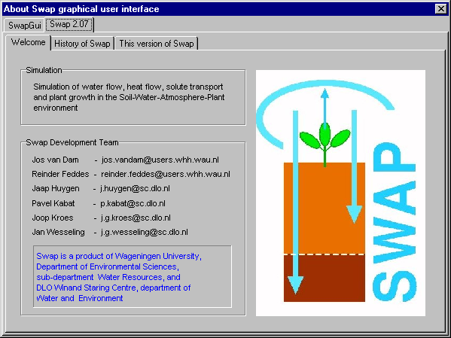

J. Huygen

J.C. van Dam

J.G.Kroes

January 2000

Contents

1 Introduction 5

2 The input menu 7
2.1 Swap input file requirements 9
2.2 Input/Key 11
2.3 Input/Meteo/ daily data 15
2.4 Input/Meteo/ detailed rainfall 19
2.5 Input/Irrigation/ Fixed irrigations 21
2.6 Input/Irrigation/ Scheduled irrigations 23
2.7 Input/Crop/ Calendar 27
2.8 Input/Crop/data/ detailed model 29
2.9 Input/Crop/data/ detailed (grass only) model 37
2.10 Input/Crop/data/simple model 43
2.11 Input/Soil/ profile description 47
2.12 Input/Soil/layer: hydraulic properties 53
2.13 Input/Drainage/ basic 57
2.14 Input/Drainage/ extended 61
2.15 Input/Bottom Boundary Condition 67
2.16 Input/Solute transport 71
2.17 Input/Heat transport 73

3 The Run menu 75
3.1 Run Swap as a console application 75

4 The Output menu 77
4.1 Output/ Graphs 77
4.2 Output/ Balances 85
4.3 Output/ 3D Vap viewer 87

5 The Tools menu 91

6 The Utilities menu 93
6.1 Utilities/Check Input Files 93
6.2 Utilities/Set & remove user programs 95

References 97

Appendix A: Examples of SwapGui add-in programs 101
1 Poseidon 101
2 SwapWin 102

1 Introduction

Swap graphical user interface (SwapGui) is an integrated simulation environment for preparing and analysing Swap input, running Swap in a Dos box, running user defined Windows programs and visualising and analysing model output. It has been developed as a Delphi application, written in object Pascal.

Acknowledgements
Rutger Vervoort has contributed to the help text and the output visualisation part of the program.
Jan Wesseling has shown how to program in Object Pascal.

Help
Help text available in most forms has been implemented as ordinary (rich) text files, that can be modified by the user using a text editor like Wordpad or Word.

Start
To start the program, double click SwapGui.Exe in the appropriate directory or create a shortcut to SwapGui.Exe. The start up screen has been depicted in figure 1.1

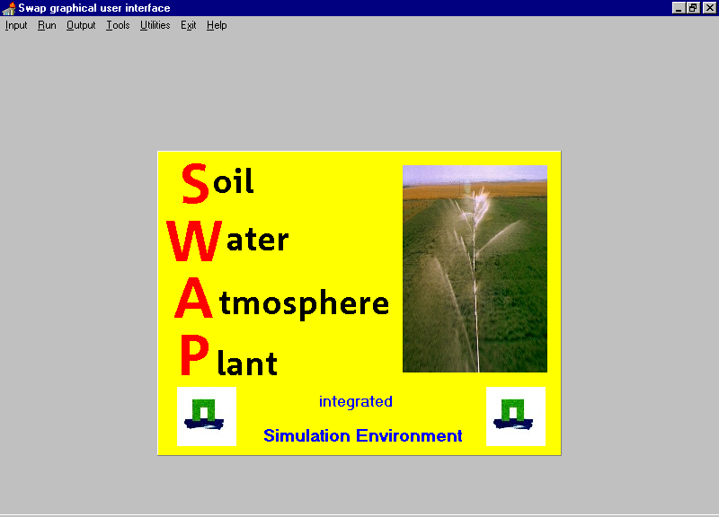

Figure 1.1 Main form of Swap graphical user interface, start up situation

2 The input menu

The input menu enables the user to prepare any of the input files required by Swap:
- key file,
- meteo file with daily data,
- meteo file with detailed rainfall data,
- file with fixed irrigations,
- file with irrigation scheduling criteria,
- file with crop rotation scheme,
- file with crop data for the detailed crop model, the detailed grass only model and the simple crop model,
- file with soil profile description,
- file with soil hydraulic properties for a certain soil layer,
- file with drainage data (basic drainage option),
- file with drainage data (extended drainage option)
- file with bottom boundary condition
- file with solute transport parameters
- file with soil heat transport parameters.

Input menu options followed by an ellipsis (…) directly lead to the associated input form, while menu options followed by the ► character are followed by a submenu (figure 2.1).

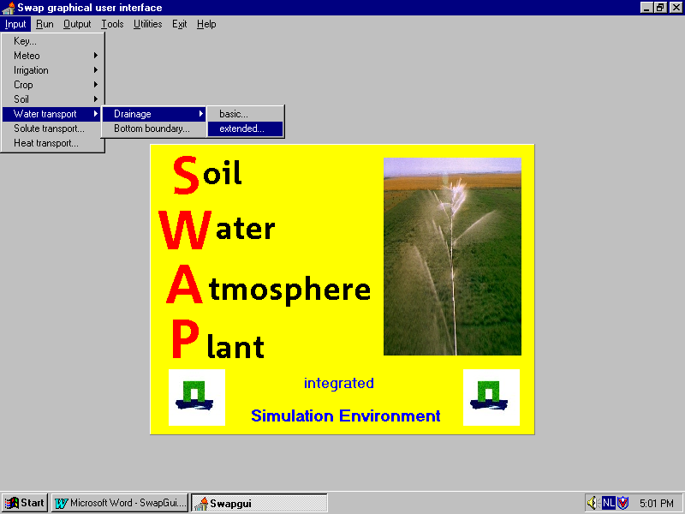

Figure 2.1 The input menu items

2.1 Swap input file requirements

Table 2.1 provides a link between Swap input menu options and the related Swap input files. For a simulation with bare soil, the user should at least prepare the input files with general information (*.KEY), daily meteo data (*.YYY), soil profile description (*.SWA), soil hydraulic functions (*.SOL) and bottom boundary conditions (*.BBC). In case the cultivated soil is simulated, in addition at least the input files with crop calendar (*.CAL) and crop growth data (*.CRP) are needed. The remaining files are used for additional features.

Table 2.1: Link between input menu options and Swap input file requirements
Menu option | File content | Name | Compulsory | Optional | Paragraph
Key | General information | *.KEY | + |  | 2.2
Meteo | Daily data | *.YYY | + |  | 2.3
Meteo | Detailed rainfall | *R.YYY |  | + | 2.4
Irrigation | Fixed | *.IRG |  | + | 2.5
Irrigation | Calculated | *.CAP |  | + | 2.6
Crop | Calendar | *.CAL |  | + | 2.7
Crop | Detailed crop | *.CRP |  | + | 2.8
Crop | Detailed grass | *.CRP |  | + | 2.9
Crop | Simple crop | *.CRP |  | + | 2.10
Soil | Soil water & profile | *.SWA | + |  | 2.11
Soil | Hydraulic functions | *.SOL | + |  | 2.12
Drainage | Basic | *.DRB |  | + | 2.13
Drainage | Extended | *.DRE |  | + | 2.14
Bottom bound. | Boundary cond. | *.BBC | + |  | 2.15
Solute transport | Solute transport | *.SLT |  | + | 2.16
Heat transport | Heat transport | *.HEA |  | + | 2.17

A Swap simulation run consists of one or more sub-runs, defined as a simulation over a period of up to one year.
Sub-runs may be arranged sequential, in this way enabling a simulation run over a period longer than one year, or parallel so that several simulations for a certain period equal or less than one year can be carried out in one run.
A sub-run comprises a time period which maximally spans one year, but that can never exceed an agricultural year boundary. For instance, if May has been defined to be the first month of the agricultural year, than a simulation run from 15 April to 15 May consists of two sub-runs, although the period itself is far less than one year. On the other hand, a simulation run from 1 May to 30 April next year requires only one sub-run although two calendar years are involved.
Files with meteorological data (*.YYY and *R.YYY) always belong to a calendar year because these data are normally stored in data bases that are not aware of the agricultural year concept. The remaining input files that list time dependent data, e.g. irrigation gifts or groundwater levels, should start before or at the first calculation day in case of parallel sub-runs or the first sub-run of a sequential run. The files for all following sequential sub-runs should start at the first day of the agricultural year.

Input files valid for the whole simulation period are: *.KEY, *.SWA, *.SOL, *.SLT and *.HEA. All other files are valid for one sub-run only.

2.2 Input/ Key

Some options are shared by all the input forms, and will be discussed only once. This applies to the ‘New’ button, which clears the form, the ‘Load’ button, which opens an existing key file, and the ‘Save’ and ‘Save as’ buttons. The ‘Rcheck’ button starts range checking of all entered numerical values. The form is closed with the ‘Exit’ button. Also each file has a comment section. The comment will be read from, or written to the input file. This can be used to identify input files.

Input/key/ page General (figure 2.2)

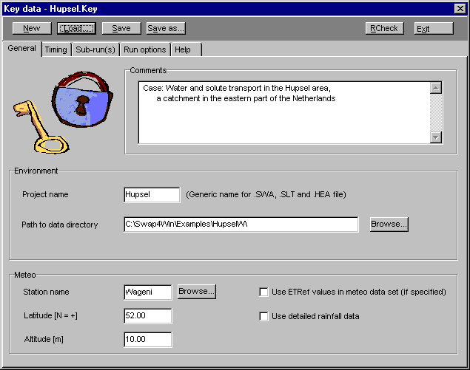

Figure 2.2 The General page of the key form

Environment

The project name (maximum of 8 characters) will be used as a generic file name for several input files, notably the .SWA file (water flow data), the .SLT file (solute transport data) and the .HEA file (heat flow data). The path should indicate the directory where the user wants to store input and output files. An example is: 'c:\Swap\example\'.

Meteo
The station name should be not longer than 7 characters, as it functions as the first part of the daily weather file name and of the detailed rainfall file name. The file extensions are derived from the three least significant figures of a year number. For example: the file with the name 'ST34567.999' contains meteo data from station ST34567 and year 1999. Note that internally Swap calculates with the whole year number (4 digits), so that no millenium problem will occur.

Latitude should be entered in degrees and decimal degrees. Altitude is relative to mean sea level.

Swap is able to calculate potential evapotranspiration rates from daily meteorological data. However, as an alternative, the user may select reference evapotranspiration values in the meteo file. In that case reference evapotranspiration values are linked to crop potential evapotranspiration by means of crop factors as specified in the crop data set.

In addition to daily rainfall data in the meteo files, detailed short time step rainfall data may be specified in a separate data file. The user should indicate if such a file should be used. A file with detailed rainfall related to the meteo data file given above, should have the name 'ST34567R.999'.

Input/ key/page Timing (figure 2.3)

Time variables - simulation

Start and end of the simulation period must be specified. The maximum length of the simulation period currently amounts 70 years. For the definition of agricultural year, see the paragraph on Swap input file requirements.

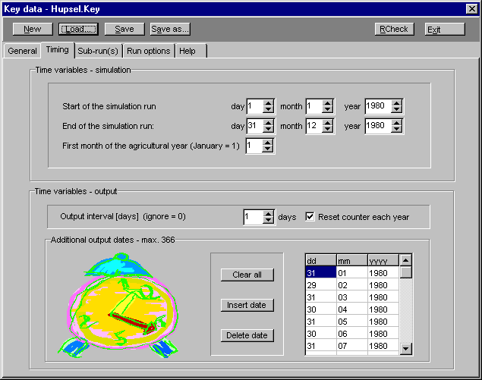
Figure 2.3 The Timing page of the key form

Time variables - output
Swap output can be generated at regular intervals The day counter which signals the end of an output interval, may be reset at the end of each agricultural year or just proceed. Additionally output can be produced at (ir)regular spaced output dates which must be specified explicitly.

Input/Key/ page Sub-runs (figure 2.4)

As discussed before, some input files are valid for the whole simulation period: general information (*.KEY), soil profile description (*.SWA), soil hydraulic functions (*.SOL), solute transport data (*.SLT), and heat flow data (*.HEA). Other input data may vary for each sub-run: the associated filenames (no extensions !) can be specified on this page. Fields for optional files that are not required for a sub-run may be left blank.

Fixed irrigations - (optional) input file with fixed irrigations [.IRG].

Crop calendar - (optional) input file with the crop rotation scheme [.CAL].
Drainage - (optional) input file for the basic [.DRB] or extended [.DRE] drainage routine.

Bottom boundary - input file with the bottom boundary condition [.BBC].
Output - generic name of output files (*.WBA, *.SBA, *.VAP, *.DRF, *.SRF, *.MAN, *.CR#, *.SC#,) of a sub-run.

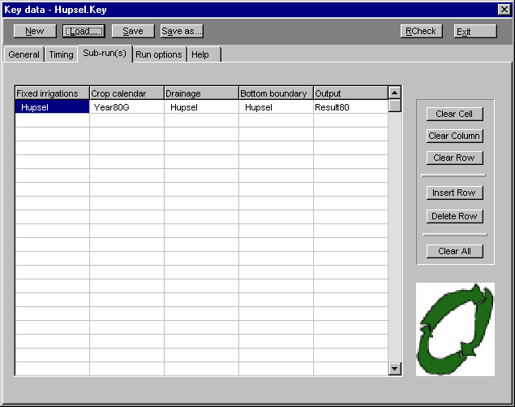
Figure 2.4 The Sub-runs page of the key form

Input/Key/ page Run options (figure 2.5)

Simulation options
For the simulation of lateral drainage three options are available:
- no simulation of lateral drainage;
- simulation with the basic drainage routine (lateral drainage to maximally five drainage levels, no simulation of the surface water balance);
- simulation with the extended drainage routine (lateral drainage to maximally five drainage levels, with simulation of the surface water balance).

The possibility to simulate solute and heat transport can just be switched on or off.

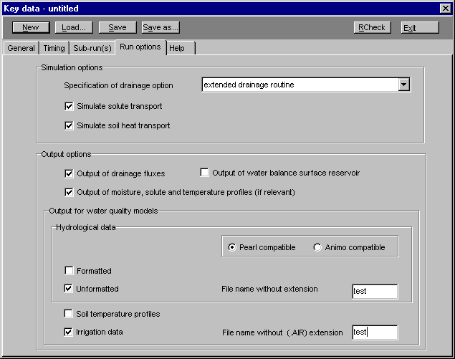

Figure 2.5 The Run options page of the key form

Output options

Here the user may specify whether two additional output files of the extended drainage routine and one file with various soil profile data must be produced. The profiles file lists for each output day soil moisture, solute concentration, soil temperature, soil water flux and solute flux as function of depth below the soil surface. This file may consume a considerable amount of disk space.

Output for water quality models like Pearl and Animo is discussed in detail in the Swap users guide (Kroes et al., 1999). Options can be switched on and off and names for the related output files can be specified.

2.3 Input/Meteo/ daily data )

This menu option allows preparation or modification of a daily weather data set.
Swap uses data of solar radiation, air temperature, air humidity, and wind speed to calculate potential evapotranspiration rate with the Penman-Monteith equation (Smith, 1991). Rainfall data should be specified for each day, but in addition the actual rainfall intensities may be specified at menu option Input/Meteo/ detailed rainfall.

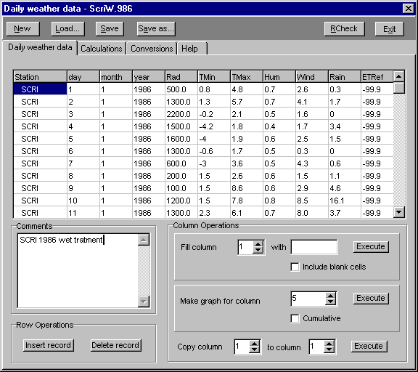
Figure 2.6 Menu option Input/Meteo/ daily data/Daily weather data

Input/Meteo/daily data/ page Daily weather data (figure 2.6)

Meteo data filename
The daily meteo data file should be saved as 'STATION.YYY' where 'STATION' is the name of the meteo station (maximum 7 characters) and 'YYY' are the three least significant digits of the year number. An example of the daily meteo file for station Wageningen of year 1998 is: 'Wagenin.998'. Internally Swap will calculate with the complete year number, in order to avoid the millenium problem.

Requirements
The following rules apply to input of meteorological data:
- Missing values should be indicated with -99.0 or lower.
- Missing values of rainfall are never allowed.
- If potential evapotranspiration must be calculated, no missing values are allowed in the columns Rad, Tmin, Tmax, Hum and Wind. Potential evapotranspiration will be calculated in case ETref values are not used (specified at menu option Input/Key/ page General), or when ETref values are missing.
- Missing values of Tmin and Tmax are not allowed if crop development speed or soil temperature must be simulated.
- Missing values of Rad are not allowed in case the detailed crop model or the detailed grass model is active.

Row and Column operations
The input data can be manipulated using these options. The row operations can be used to insert or delete records. The column operations can be useful if the data need to be edited, or screened. For instance one may load a file with only numerical values of e.g. rainfall and evapotranspiration data. These data can be moved to their proper locations using column operations.
Columns can be filled with a constant value or can be displayed graphically to check for errors. The 'include blank cells' option needs to be checked if also empty cells must be filled.

Input/Meteo/daily data/ page Calculations (figure 2.7)

More Column Operations
Columns Rad, Tmin, Tmax, Hum, Wind, Rain and ETref can be modified by adding or multiplying with a constant value.

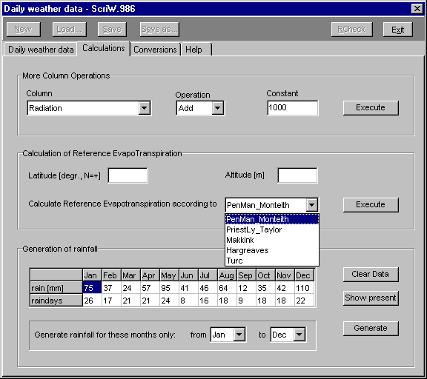
Figure 2.7 Menu option Input/Meteo/daily data/Calculations

Calculation of reference evapotranspiration
Column ETRef in the data grid can be filled with data calculated from values in columns Rad, TMin, TMax, Hum and Win, according to one of five well known methods. The methods comprise: Penman-Monteith (Monteith, 1965 and 1981), Priestly-Taylor (Priestly and Taylor, 1972), Makkink (De Bruin, 1987), Hargreaves (Hargreaves and Samani, 1985) and Turc (Turc, 1961).See Allen et al. (1994) for an overview of these methods.

Generation of rainfall
The rainfall generator requires as input the monthly rainfall and the amount of rainfall days.
The monthly rainfall is distributed over the rain days according to a gamma distribution (Berman, 1971).
For instance you may create a dry summer from an existing data set is as follows:
- first click the ‘Show present’ button to analyze the present rainfall time series
- then indicate for which month(s) you want to produce new rainfall data and for those month(s) reduce the amount of rainfall and the number of raindays
- click ‘Generate’ to actually start the generation of new daily rainfall data
Column Rain of the data grid will be modified and the new data set can be saved to a file.
Input/Meteo/daily data/ page Conversions (figure 2.8)

Swap requires the standard format for global radiation (kJ/m2/d), minimum and maximum air temperature (ºC), air humidity (kPa) and windspeed (m/s at screen height of 2 m). Sometimes meteodata are available in a different format, therefore a set of conversion operations is available to convert values from the mostly used formats to standard format.

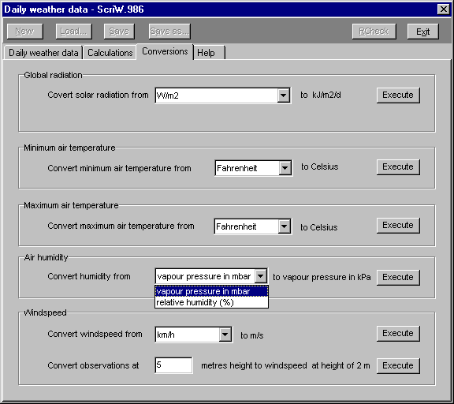
Figure 2.8 Menu option Input/Meteo/daily data/Conversions
2.4 Input/Meteo/ detailed rainfall (figure 2.9)

At this menu option a file with detailed rainfall data can be loaded or data can be entered manually. Detailed rainfall data, which represent the actual rainfall intensities, are necessary if runoff or preferential flow needs to be simulated accurately.

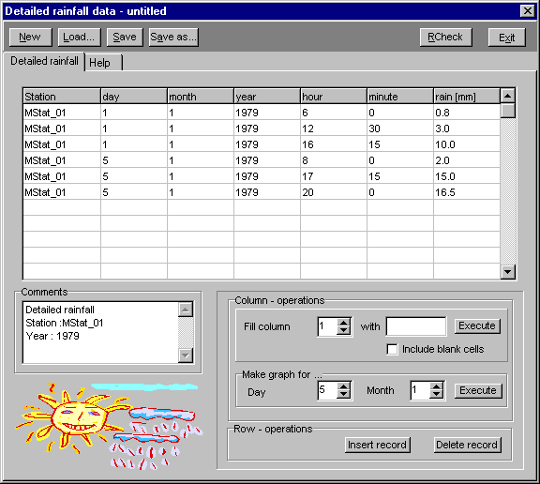
Figure 2.9 Menu option Input/Meteo/ detailed rainfall

Rainfall data filename
The detailed rainfall meteo data file should be saved as 'STATIONR.YYY' where 'STATION' is the name of the meteo station (maximum 7 characters), the 'R' denotes rainfall detailed and the extension 'YYY' consists of the last three digits of the year number. An example for station Wageningen and year 1998 is: 'WageninR.998'.

Data Entry
Each data record represents a reading from a rain gauge, which is empty at 00.00 hours and will be emptied again at the end of the day (24.00 hours). This means that rainfall data entered should be cumulative over 24 hours.

Row and Column operations
The input data can be manipulated using these options. The row operations can be used to insert or delete records. The column operations can be useful if the data need to be edited, or screened. Columns can be filled at once with one value or can be displayed graphically to check for errors. The 'include blank cells' option needs to be checked if empty cells also need to be filled.

2.5 Input/Irrigation/ Fixed irrigations (figure 2.10)

Two different types of irrigation can be specified in Swap. Either a fixed irrigation can be specified, or an irrigation can be calculated for a specific crop according to a number of criteria. A combination of fixed and calculated irrigations is also possible. An example of this is a fixed irrigation (preparation of the seed bed) before planting and calculated irrigations based on soil moisture conditions after planting. Fixed irrigations can be applied the whole year round, irrigation scheduling can only be active during a cropping period. Both types of irrigation may overlap, but a fixed irrigation has priority: if an irrigation is prescribed on a certain day, no irrigation will be calculated for the same day.

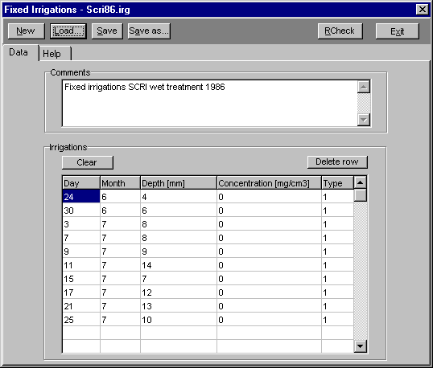
Figure 2.10 Menu option Input/Irrigation/ Fixed irrigations

Irrigations
For each agricultural year, up to 366 different fixed irrigations can be specified.

The type of irrigation can be specified as being a sprinkling (0) or a surface (1) irrigation. In case of sprinkling irrigation, interception will be calculated.

2.6 Input/Irrigation/ Scheduled irrigations

Two different types of irrigation can be specified in Swap. Either a fixed irrigation can be specified, or an irrigation can be calculated (in literature the term ‘scheduled’ is more common) for a specific crop according to a number of criteria. A combination of fixed and calculated irrigations is also possible. An example of this is a fixed irrigation (preparation of the seed bed) before planting and scheduled irrigations based on soil moisture conditions after planting. Fixed irrigations can be applied the whole year round, irrigation scheduling can only be active during a cropping period. Both types of irrigation may overlap, but a fixed irrigation has priority: if an irrigation is prescribed on a certain day, no irrigation will be scheduled for the same day.

Scheduling irrigation can be attractive if certain objectives need to be reached in crop production, like economic maximum returns. In order to generate irrigations, the irrigation scheduling file should be included in a crop rotation scheme.

Input/Irrigation/ Scheduled irrigations/ page General (figure 2.11)

The water quality of the irrigation water and type of irrigation should be defined. In case of surface irrigation, no interception is calculated.

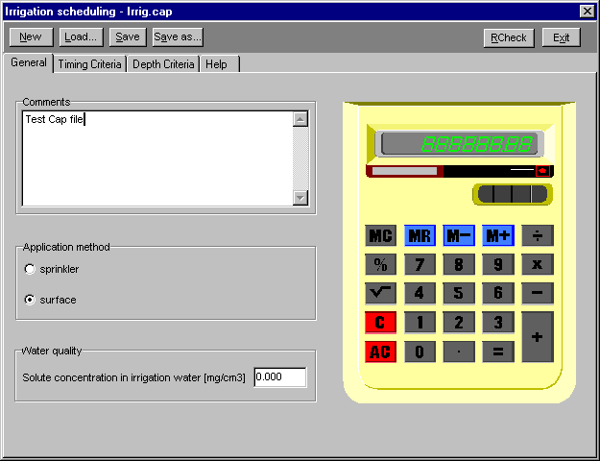
Figure 2.11 Menu option Input/Irrigation/Scheduled irrigations/ General

Input/Irrigation/ Scheduled irrigations/ page Timing Criteria (figure 2.12)

One of five different timing criteria can be chosen:

- Allowable daily stress (ADS). This criterion specifies the critical fraction of the potential transpiration rate. In case the ratio actual transpiration/ potential transpiration is equal or lower than this critical fraction, which is calculated from the actual soil moisture content and the soil moisture retention curve, an irrigation is scheduled for the next day.
- Allowable depletion of readily available water (RAW). This criterion specifies the depletable fraction of the amount of water in the root zone between h = -100 cm (field capacity) and the pressure head at which water uptake is reduced (h₃, fig. 2.2 of Swap manual), before irrigation should be started. The point of reduced water uptake depends on the atmospheric demand. Note that criteria 1 and 2 may include salinity stress if salts are present.
- Allowable depletion of totally available water (TAW). This criterion specifies the depletable fraction of the amount of water in the root zone between h = -100 cm (field capacity) and wilting point (h₄, fig. 2.2 of Swap manual), before irrigation should be started.
- Allowable depletion amount (ADA). This criterion specifies a maximum amount of water which can be extracted from the root zone below h = -100 cm (field capacity), before irrigation should be started.
- Critical pressure head or moisture content (CPM). In this case irrigation is initiated as soon as a hypothetical sensor in the soil indicates that the pressure head or moisture content drops below the specified value. This is typical in many automated irrigation systems. At this criterion the user should also specify the sensor depth.

Each of the options gives the opportunity to define the timing criteria as function of crop development stage. We may allow a crop a different water and/or salinity stress depending on the crop development stage.

The graph option can be used to check visually whether the selected criterion matches the user's ideas.

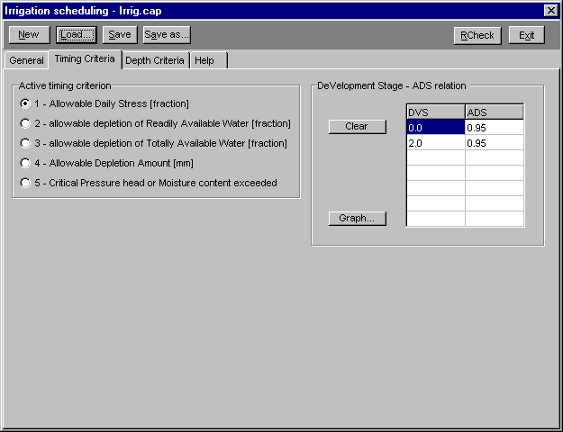
Figure 2.12 Menu option Input/Irrigation/Scheduled irrigations/Timing criteria
Input/Irrigation/ Scheduled irrigations/ page Depth Criteria (figure 2.13)

The back to field capacity option is useful in case of sprinkler or drip irrigation. In this option the profile is brought back to field capacity. An over (positive) or under (negative) irrigation amount can be specified as function of the crop development stage. This can be useful if salts need to be leached (over irrigation) or regular rainfall (under irrigation) is expected.

The fixed depth irrigation is generally used when gravity irrigation systems are simulated, which generally allow little variation in application depth. Again it is possible to specify the irrigation amount as function of the development stage of the crop.

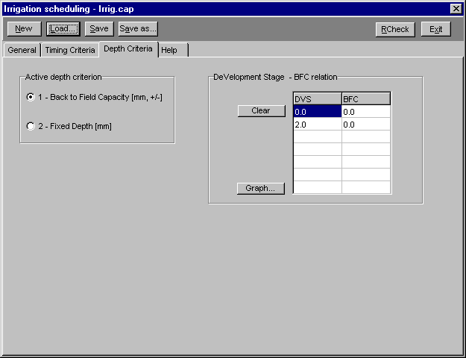
Figure 2.13 Menu option Input/Irrigation/Scheduled irrigations/Depth Criteria

2.7 Input/Crop/ calendar (figure 2.14)

Up to three crops can be simulated in each agricultural year. Only one crop can grow in the field at one time, so emergence and harvest dates should be sequential and may not overlap. For each crop in the sequence, crop model type, crop parameter file, emergence and harvest dates and (optionally) the file with irrigation scheduling characteristics need to be specified.

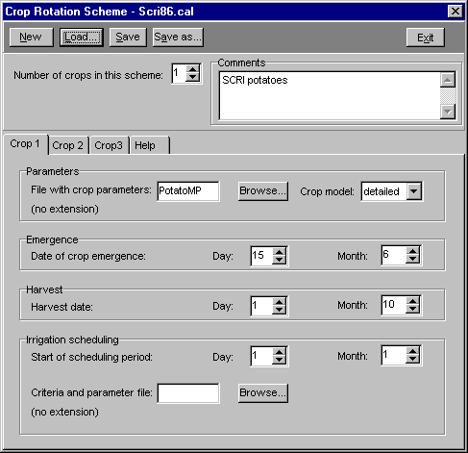
Figure 2.14 Menu option Input/Crop/ calendar

Crop model type
The type of crop model (detailed, detailed grass only or simple) should be indicated. During an agricultural year with multiple crops, a combination of these three model types can be used.

Emergence
Indicate the month and day of crop emergence. The emergence date should not be prior to an earlier crop's harvest date.

Harvest
The harvest date specifies the forced end of crop growth. Crop growth ends at this date or at crop maturity, whichever comes first.

Irrigation scheduling
Indicate the day irrigation scheduling according to specific criteria should start. In most cases this coincides with crop emergence. However a different date can be indicated, according to the users preferences. Irrigation is switched off by setting the start of the irrigation scheduling period later than the harvest date or by not specifying a ‘criteria and parameter’ file.

2.8 Input/Crop/data/ detailed model

For the detailed crop model , the crop growth part of simulation model WOFOST (Supid et al., 1994) has been chosen. In WOFOST the daily dry matter increase is calculated as the production of assimilates minus the respiration losses. This dry matter increase is partitioned to the major plant organs: roots, leaves, stems and storage organs. The rates of these processes and the pattern of dry matter distribution are determined by the present crop status and its response to controlling environmental conditions. The crop growth curve and the resulting yield level are found by integrating the daily dry matter increase, partitioned to the plant organs, over the total crop growth period. Crop growth is simulated over the period from emergence to end of active growth (maturity) with time steps of one day.

Input/Crop/data/detailed model/ page 1 (figure 2.15)

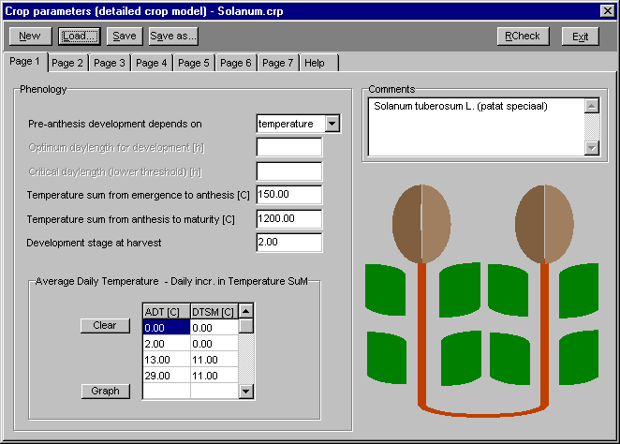
Figure 2.15 Menu option Input/Crop/data/detailed model/ page 1

Growth simulation starts at the emergence date, specified by the user in the crop calender file. A crop passes through the successive phenological stages from 0 to 2, depending on the development rate. The development rate can depend either on temperature or daylength or both. In modern cultivars, the daylength can generally be ignored if an appropriate temperature sum is chosen. For more information check the Swap theory manual , par. 7.2.

If temperature is chosen, appropriate temperature sums should be defined which will determine the development stage of the crop. If daylength is chosen, appropriate optimum and threshold daylengths should be defined to determine the reduction factor for the development rate of the crop. If the combination option is chosen, the user should specify both the temperature and the daylenght parameters. The development stage at harvest should be defined (normally equal to 2.0).

The daily increase in temperature sum does not need to be linear. It is conceivable that the increase is lower at higher average temperatures. The relationship can be defined in a maximum of 15 data pairs. A graph option is provided for the user to check the entered data graphically.

Input/Crop/data/detailed model/ page 2 (figure 2.16)

Initial
The initial growth parameters needed are the initial crop weight, the leaf area index and the maximum relative increase of LAI.

Crop factor or crop height as function of development stage is required to convert potential evapotranspiration of a reference crop (grass with a height of 12 cm) – either input or calculated using the Penman-Monteith equation - to potential evapotranspiration of the actual crop.

Green area
To calculate total assimilation it is necessary to know the green area of the stems and storage organs since these areas absorb radiation.

In the second (assimilates limited) growth stage the maximum increase of leaf area index is determined by the specific leaf area. The specific leaf area of a crop can differ depending on the development stage. Swap allows introduction of a curve describing the specific leaf area in up to 15 data points as a function of development stage.

Under optimal conditions (constant 35 °C) leaves have a certain life span. The life span of the leaves is limited by lower temperatures. Apart from the optimal temperature of 35 °C, a lower threshold temperature, which is crop specific, should be specified.

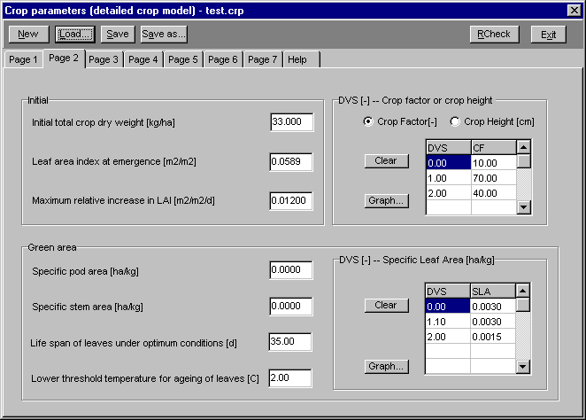
Figure 2.16 Menu option Input/Crop/data/detailed model/ page 2

Input/Crop/data/detailed model/ page 3 (figure 2.17)

This page contains the parameters needed to calculate the gross assimilation rate. Detailed information about the assimilation calculations can be found in par. 7.3 through 7.5 of the Swap theory manual. Using the absorbed radiation ( based on incoming solar radiation and two extinction coefficients) , taking into account photosynthetic leaf characteristics and possible reduction factors, the potential gross photosynthesis is calculated.

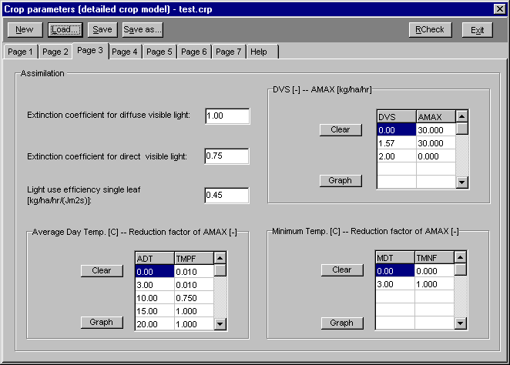
Figure 2.17 Menu option Input/Crop/data/detailed model/ page 3

The maximum CO2 assimilation rate (AMAX) is a function of the development stage (DVS). The user can enter a specific relationship (up to 15 data pairs) to characterize this relationship.

The reduction factor (TMPF) based on average daily temperature (ADT) accounts for sub-optimum temperatures. The input allows for a relationship defined by up to 15 data pairs

The influence of the minimum day temperature (MDT) on the reduction factor of AMAX (TMNF) also can be defined by a relationship of up to 15 data pairs.Low night temperatures hamper transformation of assimilates.

Graphing is possible to visualize the defined relationships.

Input/Crop/data/detailed model/ page 4 (figure 2.18)

Part of the assimilates are used to provide energy for the maintenance of the existing live biomass (maintenance respiration).

An increase in temperature causes an increase in maintenance respiration. Generally a 10 ºC temperature increase causes maintenance respiration to increase by a factor 2.
Maintenance requirements are approximately proportional to the dry weights of the plant organs to be maintained.
Senescence will decrease respiration. The reduction factor (RFSE) is crop specific and may depend on crop development stage (DVS). The user can enter up to 15 data pairs to define this relationship while graphing is possible to visualize the defined relationship.

The remaining carbohydrates are converted into structural matter. In this conversion, some of the weight is lost as growth respiration, which is taken into account by means of conversion efficiencies.

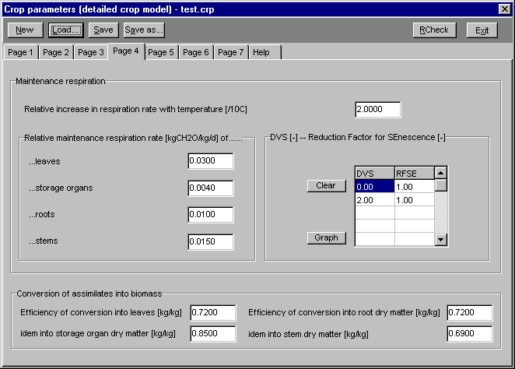
Figure 2.18 Menu option Input/Crop/data/detailed model/ page 4

Input/Crop/data/detailed model/ page 5 (figure 2.19)

The partitioning of the produced structural plant material to the different plant organs is defined by partitioning factors (FR, FL, FS, FO), which each depend on crop development stage (DVS). Note that the sum of the partitioning factors for leaves, stems and storage organs (thus without roots) should equal 1.0 at any development stage ! See Par. 7.8 of the Swap manual. For each partitioning factor a relationship in up to 15 data pairs can be defined. Graphing is possible to visualize the defined relationships.

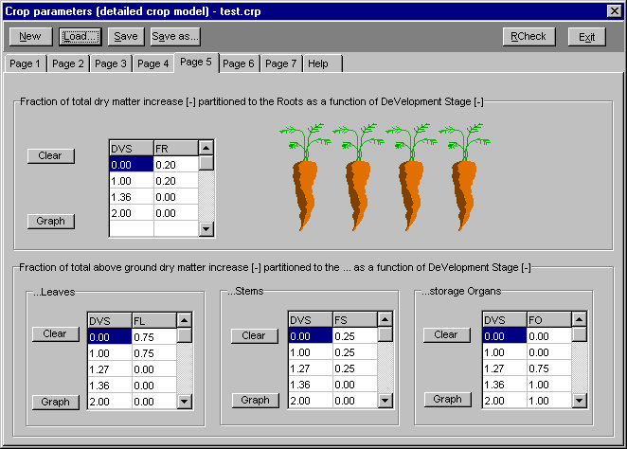
Figure 2.19 Menu option Input/Crop/data/detailed model/ page 5

Input/Crop/data/detailed model/ page 6 (figure 2.20)

The death rate of the storage organs is considered to be zero. The user can specify a death rate of the roots (RDRR) and stems (RDRS) as function of crop development stage (DVS) (up to 15 data pairs). Graphing is possible to visualize the defined relationships. The death rate of the leaves is somewhat more complicated (see Par. 7.9 of the Swap manual), and has already partly been defined on input page 2. Here the user needs to define the death rate due to water and/or salinity stress.

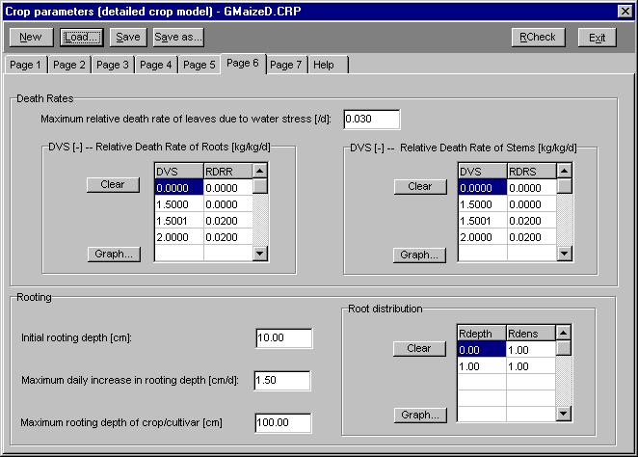
Figure 2.20 Menu option Input/Crop/data/detailed model/ page 6

Root growth is calculated rather straightforward. The user needs to define the initial rooting depth (RDI), the maximum daily increase (RRI) and the maximum rooting depth (RDC). The daily increase is equal to the maximum daily increase unless too few assimilates are available or the maximum rooting depth is reached.

The user may enter up to 11 data pairs to define the relative root density (Rdens) as function of the relative rooting depth (Rdepth). The user may use any unit for the root density, Swap will normalize the root density distribution.

Input/Crop/data/detailed model/ page 7 (figure 2.21)

Both water and salinity stress may limit the crop potential transpiration. Swap assumes that the reduction factors due to water and salinity stress can be multiplied to derive the total reduction.

The user should enter the pressure heads defining the reduction of root water extraction, as depicted in fig. 2.2 of the Swap manual. At high atmospheric demand, actual transpiration might decrease earlier than at low atmospheric demand. Therefore the user should specify the levels of high and low atmospheric demand. Swap assumes a linear relation between the critical pressure heads at low and high atmospheric demand.
Reduction of water uptake due to salt stress needs input of the crop salt threshold value (critical EC value above which salt stress occurs) and the decline of root water uptake above this threshold level, according to the Maas and Hoffman (1977) concept .

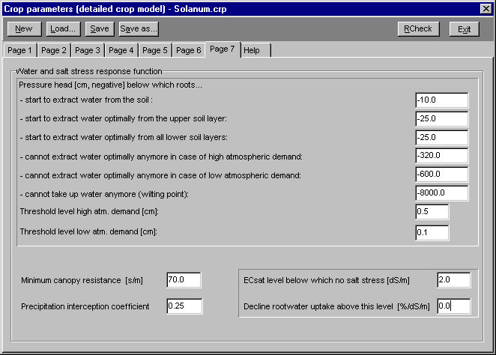
Figure 2.21 Menu option Input/Crop/data/detailed model/ page 7

Minimum canopy resistance is used in the Penman-Monteith equation to calculate potential evapotranspiration rate.
The precipitation interception coefficient is used to calculate the amount of precipitation according to the Braden (1985) concept . At increasing precipitation amounts, the amount of interception assymptotically reaches the value interception coefficient times LAI (cm), where LAI is the leaf area index. A value of 0.0 effectively discards interception.

2.9 Input/Crop/data/ detailed (grass only) model

The crop growth routine of the WOFOST model was adapted for grass growth with the following assumptions:
- the grass species consists of perennial ryegrass;
- the sward is regularly mowed and remains vegetative;
- no grazing takes place;
- the grassland is permanent.

As grass growth remains vegetative, development stage can not be used as a time variable. In stead, day number is used to define the different time dependent relationships.

Input/Crop/data/detailed (grass only) model/ page 1 (figure 2.22)

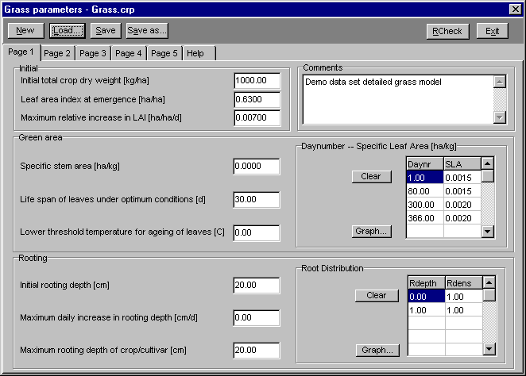
Figure 2.22 Menu option Input/Crop/data/detailed grass model/ page 1

Initial
The growth parameters needed are the initial crop weight, the leaf area index and the maximum relative increase in LAI.

Green area
To determine total assimilation it is necessary to know the green area of the stems since thisan area absorbs radiation.

In the second (assimilates limited) growth, stage the maximum increase in leaf area index is determined by the specific leaf area. The specific leaf area of a grass crop can differ depending on the season. Swap allows for introduction of a curve describing the specific leaf area in up to 15 data points as a function of the daynumber.
Under optimal conditions (constant 35 ºC), leaves have a certain life span. The life span of the leaves is limited by lower temperatures. Next to the optimal temperature of 35 ºC, a lower threshold temperature should be entered.
Rooting
Root growth is calculated rather straightforward. The user needs to define the initial rooting depth, the maximum daily increase and the maximum rooting depth. The daily increase is equal to the maximum daily increase unless too few assimilates are available or the maximum rooting depth has been reached.

The user may enter up to 11 data pairs to define the relative root density (Rdens) as function of the relative rooting depth (Rdepth). The user may use any unit for the root density, Swap will normalize the root density distribution.

Input/Crop/data/detailed (grass only) model/ page 2 (figure 2.23)

This page contains the parameters needed to calculate the assimilation rate from the solar radiation data. Detailed information about the assimilation calculations can be found in par. 7.3 through 7.5 of the Swap manual. Using the absorbed radiation ( based on incoming solar radiation and two extinction coefficients) , taking into account photosynthetic leaf characteristics and possible reduction factors, the potential gross photosynthesis is calculated.

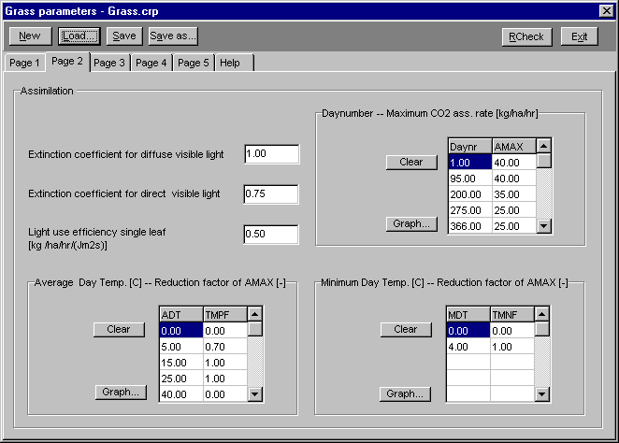
Figure 2.23 Menu option Input/Crop/data/detailed grass model/ page 2

The maximum CO2 assimilation rate (AMAX) is a function of the development stage , which for the grass model is represented by daynumber since crop emergence. The user can enter a specific relationship (up to 15 data pairs) to characterize this relationship.

The reduction factor (TMPF) based on average daily temperature (ADT) accounts for sub-optimum temperatures. The input allows for a relationship defined by up to 15 data pairs

The influence of the minimum day temperature (MDT) on the reduction factor of AMAX (TMNF) also can be defined by a relationship of up to 15 data pairs.

Graphing is possible to visualize the defined relationships.

Input/Crop/data/detailed (grass only) model/ page 3 (figure 2.24)

Part of the assimilates are used to provide energy for the maintenance of the existing live biomass (maintenance respiration).

An increase in temperature causes an increase in maintenance respiration. Generally a 10 ºC temperature increase causes maintenance respiration to increase by a factor 2.
Maintenance requirements are approximately proportional to the dry weights of the plant organs to be maintained.
Senescence will decrease respiration. The reduction factor (RFSE) is crop specific and may depend on crop development stage. The user can enter up to 15 data pairs to define this relationship while graphing is possible to visualize the defined relationship.

The remaining carbohydrates are converted into structural matter. In this conversion, some of the weight is lost as growth respiration taken into account by means of conversion efficiencies.

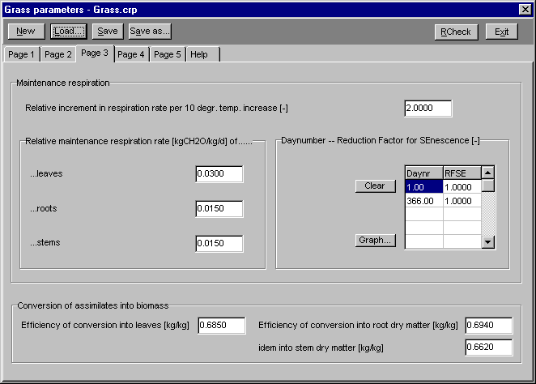
Figure 2.24 Menu option Input/Crop/data/detailed grass model/ page 3

Input/Crop/data/detailed (grass only) model/ page 4 (figure 2.25)

The partitioning of the produced structural plant material to the different plant organs is defined by partitioning factors (FR, FL, FS), which each depend on development stage (i.e. daynumber). Note that the sum of the partitioning factors of leaves and stems (thus without roots) should equal 1.0 at any development stage (see par. 7.8 of Swap manual)! For each partitioning factor a relationship of up to 15 data pairs can be defined. Graphing is possible to visualize the defined relationships.

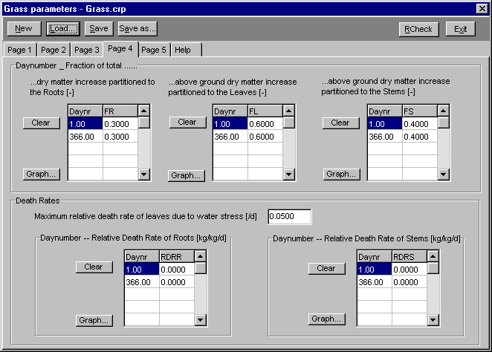
Figure 2.25 Menu option Input/Crop/data/detailed grass model/ page 4

The user can specify a death rate of the roots (RDRR) and stems (RDRS) as a function of the daynumber (up to 15 data pairs). Graphing is possible to visualize the defined relationship.
The death rate of the leaves is somewhat more complicated (see Par. 7.9 of the Swap manual), and has already partly been defined on input page 1. Here the user needs to define the death rate due to water and/or salinity stress.

Input/Crop/data/detailed (grass only) model/ page 5 (figure 2.26)

Both water and salinity stress may limit the crop potential transpiration. Swap assumes that the reduction factors due to water and salinity stress can be multiplied to derive the total reduction.

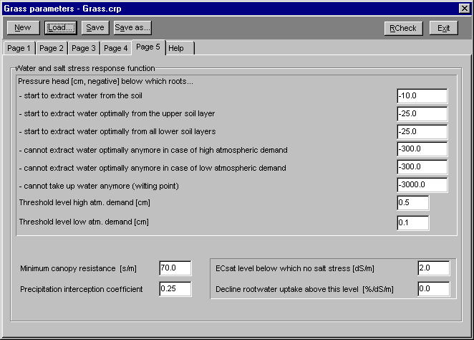
Figure 2.26 Menu option Input/Crop/data/detailed grass model/ page 5

- The user should enter the pressure heads defining the reduction of root water extraction, as depicted in fig. 2.2 of the Swap manual. At high atmospheric demand, actual transpiration might decrease earlier than at low atmospheric demand. Therefore the user should specify the levels of high and low atmospheric demand. Swap assumes a linear relation between the critical pressure heads at low and high atmospheric demand.
- Reduction of water uptake due to salt stress needs input of the crop salt threshold value ( critical EC value above which salt stress occurs) and the decline of root water uptake above this threshold level, according to the Maas and Hoffman (1977) concept.
- If the Penman-Monteith equation is used, the user needs to supply the minimum canopy resistance.
- The precipitation interception coefficient is used to calculate the amount of precipitation according to the Braden (1985) concept. At increasing precipitation amounts, the amount of interception asymptotically reaches the value interception coefficient times LAI (cm), where LAI is the leaf area index. A value of 0.0 effectively discards interception of precipitation.

2.10 Input/Crop/data/ simple model

The simple crop model is useful if accurate simulation of crop water use is more important than accurate simulation of crop yield. The simple crop growth model represents a green canopy that intercepts precipitation, transpires and shades the ground. The user specifies leaf area index (or soil cover fraction), crop height (or crop factor) and rooting depth as a function of development stage. Crop development can either be controlled by a temperature sum, or can be a function of time.

Input/Crop/data/ simple model/ page 1 (figure 2.27)

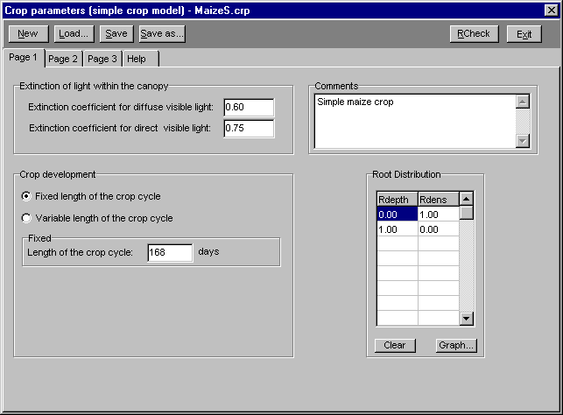
Figure 2.27 Menu option Input/Crop/data/simple model/ page 1

The extinction coefficients are needed to calculate the amount of light that reaches the soil surface, in order to calculate potential soil evaporation. They are not needed if the soil cover fraction is used to partition potential transpiration and potential evaporation.

Crop development can be either modelled linearly (fixed length of the crop cycle) or can be controlled by the temperature sum (variable length of the crop cycle). Clicking the relevant option will provide input options for additional parameters. In the case of a fixed crop cycle, only the length of the crop cycle needs to be entered. In the case of a variable length of the crop cycle, the different temperature sums need to be entered.

The user may enter up to 11 data pairs to define the relative root density (fraction of maximum density) as a function of the relative rooting depth (fraction of maximum rooting depth). Actual values for rooting depth must be specified elsewhere.

Input/Crop/data/ simple model/ page 2 (figure 2.28)

In the crop model the user needs to specify leaf area index (LAI) or soil cover fraction (SCF), crop height (CH) or crop factor (CF) , rooting depth (RD) and yield response as a function of development stage (DVS).
Crop height will be used to to determine the aerodynamic resistance in the Penman-Monteith equation. If alternatively crop factors have been specified, then Penman-Monteith will be applied on a standard crop (grass with a height of 12 cm) and the result will be multiplied by the relevant crop factor.
The yield response factor (KY) determines at each growing stage the relationship between the relative yield and the relative transpiration (defined as the ratio of the actual over the potential transpiration). In case of a linear relation between the relative crop yield and the relative transpiration, or when no information is available for the yield response factor as a function of DVS, specify KY = 1 for 0 < DVS < 2.

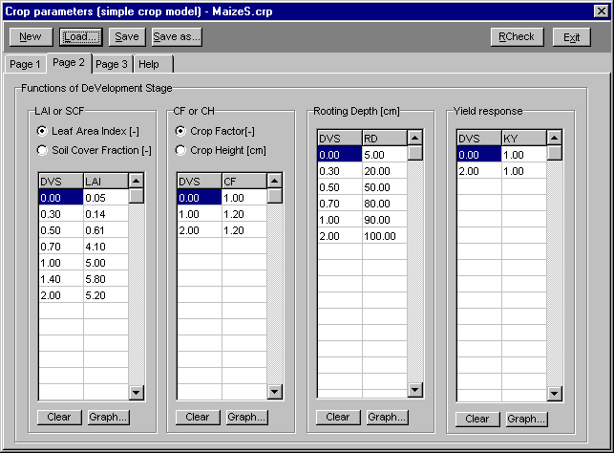
Figure 2.28 Menu option Input/Crop/data/simple model/ page 2

Input/Crop/data/ simple model/ page 3 (figure 2.29)

Both water and salinity stress may limit the crop potential transpiration. Swap assumes that the reduction factors due to water and salinity stress can be multiplied to derive the total reduction.

The user should enter the pressure heads defining the reduction of root water extraction, as depicted in figure 2.2 of the Swap manual. At high atmospheric demand, actual transpiration might decrease earlier than at low atmospheric demand. Therefore the user should specify the levels of high and low atmospheric demand.

Reduction of water uptake due to salt stress needs input of the crop salt threshold value (EC value above which salt stress occurs) and the decline of root water uptake above this threshold level, according to the Maas and Hoffman (1977) concept.

If the Penman-Monteith equation is used, the user needs to supply the minimum canopy resistance.

The precipitation interception coefficient is used to calculate the amount of precipitation according to the Braden (1985) concept. At increasing precipitation amounts, the amount of interception assymptotically reaches the value interception coefficient times LAI [cm], where LAI is the leaf area index. A value of 0.0 effectively discards interception of precipitation.

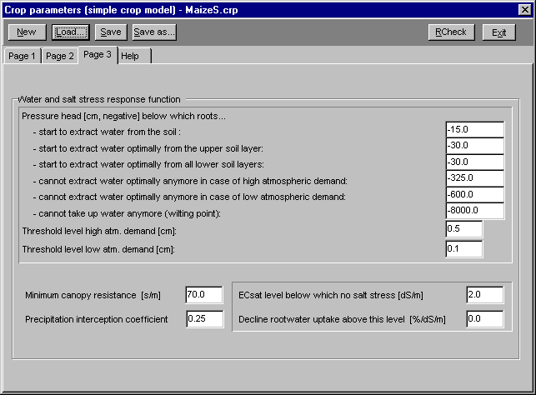
Figure 2.29 Menu option Input/Crop/data/simple model/ page 3

2.11 Input/Soil/ profile description

Input/Soil/profile description/ page 1 (figure 2.30)

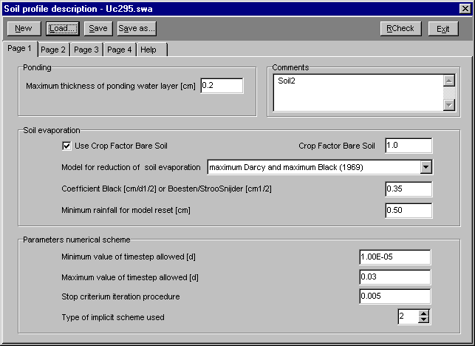
Figure 2.30 Menu option Input/Soil/profile description/ page 1

Ponding
The maximum ponding layer thickness [cm] determines which water layer can be present on top of the soil surface before runoff starts.

Soil evaporation
The crop factor bare soil converts ETref or calculated potential soil evaporation rate according to Penman-Monteith to the potential soil evaporation rate used in the Swap simulation. Although the name is confusing, the function of the factor is similar to the function of a real crop factor.
In case of a wet soil, actual evaporation equals potential evaporation (independent of soil type). When the topsoil dries, Swap calculates the actual soil evaporation rate as determined by the maximum soil water flux. To calculate the actual evaporation accurately the thickness of the top compartment should not be too large (see for detailed information paragraph 2.2 and 6.8 in the Swap manual). The manual suggests a thickness of ~1 cm.

Since the soil evaporation could be overestimated using the soil hydraulic functions, Swap allows the use of two additional, empirical functions, which can be selected under this option. Since the functions are empirical, the parameters are soil and location specific. Swap will determine the actual evaporation rate by taking the minimum value of the potential evaporation rate from meteorological data, the maximum soil water flux according to Darcy, and the maximum evaporation rates according to the empirical functions (if selected by the user).

Parameters numerical scheme
To solve the numerical scheme accurately and efficiently, Swap uses minimum and maximum time steps. The program will look for the optimal time step between the defined limits, taking the number of iterations to reach convergence as a criterion. Making the minimum time step too large might lead to instability, while making it too small will increase the calculation time substantially. Ordinary values for minimum and maximum time step are 10⁻⁸ and 0.2 day, respectively.

The stop criterion for the iteration procedure is defined between 10⁻⁵ and 0.01 and basically defines convergence. Choosing it too large could introduce errors, while choosing it too small will increase the calculation time substantially. The user should check the mass balance error in the soil water output file (*.WBA) to determine if the error is acceptable.

Two types of implicit schemes can be chosen by the user:
- Richards equation is solved twice per time step. For very simple problems, under steady state conditions or conditions in which the program reaches convergence very rapidly, this might be appropriate.
- Richards equation is solved until convergence. This is the recommended procedure for most unsaturated flow problems.

Input/Soil/profile description/ page 2 (figure 2.31)

Geometry of the soil profile
Swap allows for the definition of up to 10 soil layers. Additionally, the soil is subdivided in a maximum of 60 compartments, which are used in the finite difference scheme. Minimizing the number of compartments will decrease calculation time, but might increase the mass balance error.
For each soil layer, the bottom compartment number should be defined. The soil layers are numbered from top to bottom. For each compartment, the thickness should be defined. Note that for efficient calculation of top boundary fluxes, the compartment thickness should be small (~1 cm) near the soil surface. Two default profiles are available.

File(s) with soil hydraulic functions
Specify for each soil layer a file with soil hydraulic functions, which can be defined under the menu option: Input/Soil/layer: hydraulic properties.

Soil texture
Swap uses weight fractions of sand, silt and clay (of mineral part) and weight fraction of organic matter to calculate soil thermal properties. Only in case soil heat flow is calculated numerically, soil texture data are used.

Rooting depth limitation
The depth at which rooting is limited by the soil profile should be entered here. The program will also check the maximum rooting depth of the crop and will use the minimum of the two maximum depths as boundary when simulating root growth.

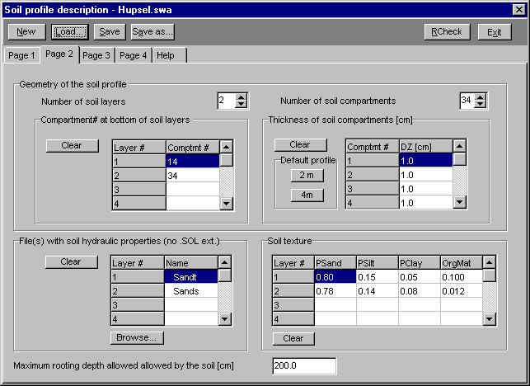
Figure 2.31 Menu option Input/Soil/profile description/ page 2

Input/Soil/profile description/ page 3 (figure 2.32)

Hysteresis
In Swap hysteresis only affects the water retention function. The hydraulic conductivity as function of soil water content is considered uniquely defined. Swap uses the scaling method of Scott et al. (1983) to derive the wetting and drying scanning curves. If hysteresis is simulated, the user should define whether at the initial condition the soil profile is wetting or drying. If the soil is initially dry and is getting wet during the simulation, the simulation should start from the initial condition wetting. Alternatively, if the initial condition is wet (for instance in winter, or after a rainstorm) the initial condition for hysteresis should be drying.

A minimum head difference to change from wetting to drying [cm] at a soil node should be specified. This parameter is introduced to avoid too quickly swapping from a wetting to a drying curve if small changes in the pressure head, in a direction opposite to the previous direction, occur.

If hysteresis is chosen by the user, the hydraulic functions should be defined with Mualem-van Genuchten parameters in the soil physical parameter file (defined under the menu option Input/Soil/layer: hydraulic properties). Tabular soil hydraulic functions don’t allow the generation of scanning curves.

Scaling of VG parameters
This option allows the scaling of the soil hydraulic functions to simulate spatial variability according to Miller and Miller (1956). For each defined scaling factor, Swap will perform another sub-run using the scaled soil hydraulic functions. These sub-runs are thus examples of parallel runs. If this option is chosen a maximum of one year can be simulated with Swap. Swap allows for the definition of 70 different scaling factors.

The user should define the number of repetitions (or scaling factors) and which soil layer should be scaled. The soil layers are numbered from the top downwards. For each repetition the user should specify a scaling factor, of which 1.0 means 'not scaled'.

Swelling/shrinkage parameters
Swap employs the clay shrinkage characteristic for the simulation of soil crack formation and water and solute transport in cracks.

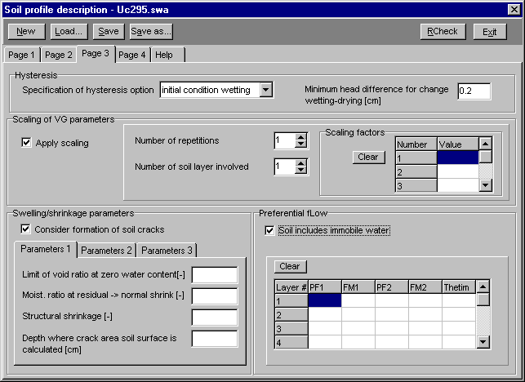
Figure 2.32 Menu option Input/Soil/profile description/ page 3

Ad Parameters 1:
The residual shrinkage stage of the shrinkage characteristic is described by an exponential relationship. The user needs to supply three points of the shrinkage characteristic and Swap will determine the necessary parameters to describe the whole curve. The points which need to be supplied are the void ratio (ε) at moisture ratio ν = 0 (zero water content), the moisture ratio at the transition of residual to normal shrinkage and the structural shrinkage ν_{s}. See for more detail figure 5.2 of the Swap manual.

If the horizontal crack area at the soil surface is used to determine infiltration into cracks, the infiltration might be underestimated due to the sharp increase of water content close to the soil surface. To prevent this, Swap allows for calculation of the horizontal crack area for infiltration at a certain depth below soil surface. Applications show that a depth of 5 cm below soil surface performs well.

Ad Parameters 2:
Shrinkage might not occur in a isotropic way, meaning that all three dimensions shrink at the same rate. This is defined by the geometry factor r_{s}, which equals 3 in case of isotropic shrinkage and equals 1 in case of vertical subsidence only. If vertical subsidence dominates cracking 1 < r_{s} < 3, if cracking dominates vertical subsidence r_{s} > 3.

The diameter of the soil matrix polygon determines the area of the crack walls relative to the surface area. The bypass flow rate of the crack storage water, which bypasses the soil matrix and directly flows to the drains, is calculated similar to linear reservoirs, using the exponential rate coefficient defined here. The effective lateral diffusion coefficient determines the rate of solute diffusion from the soil matrix to the bypassing water and has to be derived in the laboratory or from field measurements.

Ad Parameters 3:
Cracks are formed if the soil water content becomes smaller than a critical minimum value. The water content might differ depending on the amount of clay and the mineralogy of the soil. In case of moderately to heavy clay soils, the critical water content is close to the saturated water content.

Preferential flow
Swap allows for simulation of preferential flow due to unstable wetting fronts, e.g. in case of water repellent soils. The modelling concept divides the soil in a mobile (or transport) domain and an immobile (or resident) domain. The mobile fraction of the soil is defined in this menu option.
The solute exchange and diffusion coefficients for the preferential flow should be defined under the menu option Input/Solute transport.
In water repellent soils the mobile soil fraction may depend on the soil water pressure head in the mobile fraction. Swap assumes a linear relationship between log(h) and the mobile soil fraction. The user should specify the log(h) or pF value and the mobile soil fraction (FM) for two data points to define this linear relationship. If the user wants to simulate a situation in which the mobile soil fraction is not dependent on the soil water content, a constant relationship can be defined. Additionally the constant volumetric water content in the immobile fraction should be specified (Thetim), since this value may differ from the transient water content in the mobile soil fraction.

Input/Soil/profile description/ page 4 (figure 2.33)

Fate of discharge water in a regional system
If solute transport with lateral drainage is to be simulated, the drainage flux should be partitioned over the saturated layers. If the box is not checked, Swap assumes that the drainage flux leaves the model at the bottom compartment. If only water flow is simulated or a relatively small section of a deep saturated profile is simulated, this assumption is realistic. However in case of solute transport (see also chapter 10 in the Swap manual) and non-uniform soils, the vertical distribution of the groundwater flow becomes important as it directly affects the residence time of solutes.

If this option is checked by the user, anisotropy factors need to be defined for each soil layer. The anisotropy factor is the ratio of the vertical over the horizontal saturated hydraulic conductivity. The user should also specify the drain spacing in any of the drainage levels if the partitioning of the drainage flux option is checked.

Initial moisture conditions
Two types of initial moisture conditions can be defined by the user:
- The first possibility is to define the nodal pressure heads for each compartment. This option is useful if the simulated situation starts from a non-equilibrium or if no groundwater table is simulated. Note that the initial pressure heads should be entered in cm, where negative numbers indicate unsaturated conditions. Unlike water contents, soil water pressure heads are continuous with depth.
- The second possibility is to define the initial moisture conditions as an equilibrium profile with the groundwater table. In this case the nodal pressure at the groundwater table equals zero and the nodal pressure decreases linearly with height towards the soil surface. In this case the initial groundwater level needs to be specified. Note that the value specified should be negative, indicating a level below the soil surface.

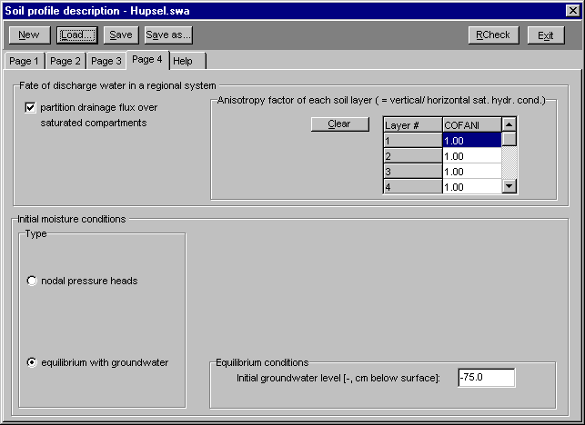
Figure 2.33 Menu option Input/Soil/profile description/ page 4

2.12 Input/Soil/ layer: hydraulic properties

For each soil layer, defined in the soil profile description, the relations between soil water pressure head, soil moisture content and unsaturated hydraulic conductivity should be specified. Swap allows either definition of these relations using a table, or using the Mualem-van Genuchten formula (Mualem, 1976, Van Genuchten, 1980). In case hysteresis , preferential flow with the mobile/immobile concept, or scaling of the soil hydraulic functions are part of the simulation run, the soil hydraulic functions should be described with the Mualem-van Genuchten formula.

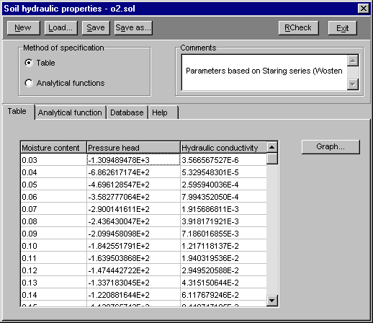
Figure 2.34 Menu option Input/Soil/ layer: hydraulic properties/ page Table

Table
If the tabular form is checked (figure 2.34), a table appears in which for each moisture content theta, the corresponding soil water pressure head and hydraulic conductivity needs to be defined. The user should start with the lowest water content, of which the corresponding soil water pressure head should be lower than -1.0E6 cm/d in order to cover the range required for field conditions . Next water content increments of 0.01 should be used until the saturated water content. The graphing option can be used to check the defined relationship visually.

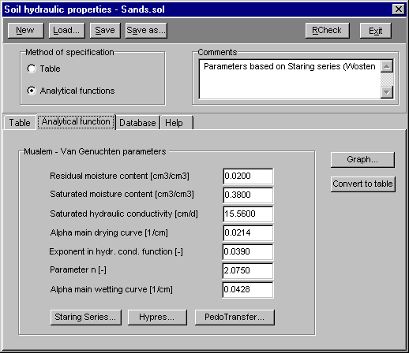
Figure 2.35 Menu option Input/Soil/ layer: hydraulic properties/ page Analytical function

Analytical function
If the analytical function option is checked (figure 2.35), the parameters of the Mualem-van Genuchten equation should be entered.
If hysteresis is to be modelled, then alpha of the main wetting curve should be provided. This value should always be larger than alpha of the main drying curve. Clicking the Graph button discloses a graphical representation of the soil hydraulic functions based on the present set of parameters (figure 2.36)

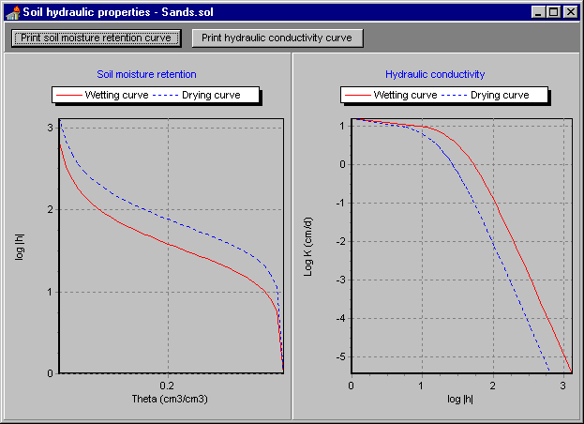
Figure 2.36 Graphical representation of soil hydraulic properties
After clicking Convert to table, a table is produced using the Mualem-Van Genuchten analytical functions.This is useful when the physical saturated conductivity differs from the parameter of saturated conductivity in the Mualem-Van Genuchten functions. Also a tabular function saves computing time.

Database
The Mualem-Van Genuchten parameters can either be filled in directly or loaded from a database present in SwapIse. Currently three datasets are provided:

1 Staring Series (figure 2.37):

SC-DLO has built up a database of 620 measured water retention and hydraulic conductivity characteristics of different soil horizons. This database has been arranged according to the main texture classes of 18 topsoils and 18 subsoils. Average characteristics have been calculated for 30 of the 36 texture classes. These average characteristics have been described analytically and can be easily included in simulation models. This dataset of soil physical characteristics is called the Staring Series (Wösten et al., 1994).

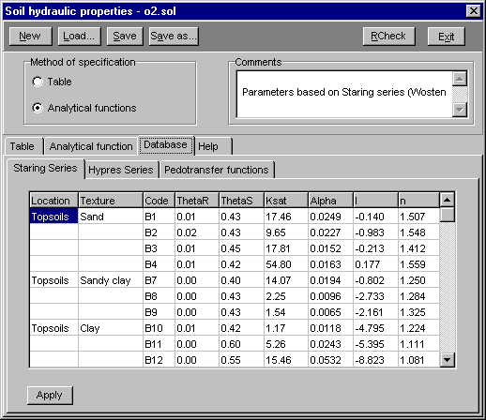
Figure 2.37 Mualem-van Genuchten parameters for the Staring Series

2 Hypres Series (figure 2.38)

Available data on hydraulic properties of European soils, which until recently were highly fragmented and resided within different institutes scattered over the whole of Europe, have been stored in one central database. This wealth of information has been used to derive a series of standard hydraulic properties of soils called Hypress (Wösten et al., 1998). In view of the nature of the information collected, the resulting Hypres series is suitable for application in studies on a European scale and provides an excellent alternative to costly and time-consuming direct measurements of these properties.

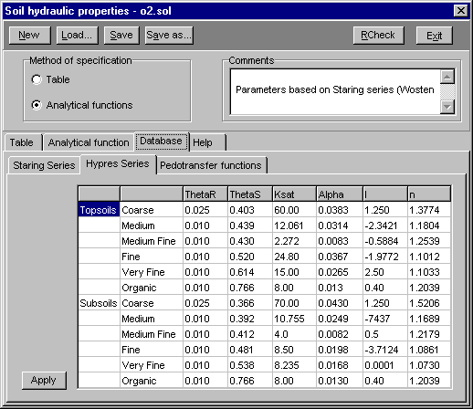
Figure 2.38 Mualem-van Genuchten parameters for the Hypres Series

3 Continuous Pedo Transfer Functions (figure 2.39)

The Mualem-van Genuchten functions using parameters from the Staring Series or the Hypres Series are called class pedotransfer functions as they predict the average hydraulic characteristics for a soil texture class. When regression techniques are used to investigate the dependency of each Mualem-van Genuchten parameter on more easily measured basic soil properties, continuous pedotransfer functions can be constructed. Continuous pedotransfer functions available in SwapIse predict the hydraulic characteristics for a specific soil with known texture, organic matter content and bulk density.They have been derived from the Hypress database.

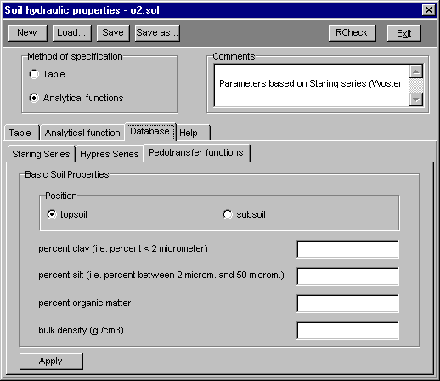
Figure 2.39 Input screen for the continuous pedotransfer functions
2.13 Input/Drainage/ basic

Swap allows for two different drainage routines. The basic drainage routine, meant for most field-scale situations and the extended drainage routine, meant for simulation of drainage at a regional level and surface water management. If the user does not want to simulate the surface water balance, the basic drainage routine should suffice. The basic drainage routine does allow for simulation of drainage through several drainage levels, with drainage and infiltration resistances.

The menu option has the choice of three methods to establish the drainage flux:
- A table with drainage flux as function of groundwater level.
- An analytical drainage function based on Hooghoudt and Ernst.
- A linear relation between drainage flux and groundwater level, which might involve different drainage levels.

Swap allows for both drainage and sub-irrigation (infiltration) through the same system. Prior to calculating the drainage or sub-irrigation rate, the program determines whether the flow situation involves drainage, sub-irrigation or neither. No drainage or sub-irrigation will occur if both the groundwater level and the surface water level are below the drainage base. Drainage will occur if the following two conditions are met:
- the groundwater level is higher than the channel bed level;
- the groundwater level is higher than the surface water level.
Sub-irrigation can only occur if the following two conditions are met:
- the surface water level is higher than the channel bed level;
- the surface water level is higher than the groundwater level.
The maximum of the surface water level and the channel bed level is used to calculate the drainage base.

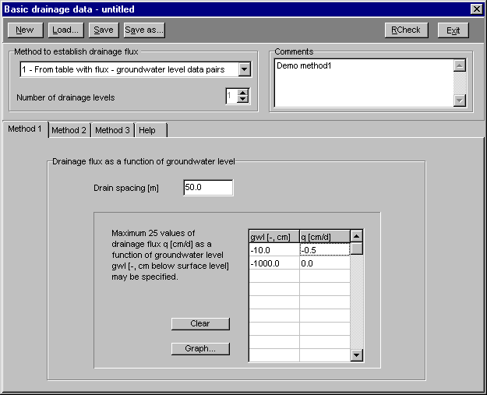
Figure 2.40 Menu option Input/Drainage/basic/ method 1
Method 1: From a table with flux-groundwater level data pairs (figure 2.40)
This option should be used if the relationship between drainage flux (q) and the groundwater level (gwl) is non-linear. Swap will linearly interpolate between the specified values. The drain spacing should be entered in [m]. Note that the drain spacing does not need to be specified if the user did not partition the drainage flux vertically (menu option Input/Soil/profile description).

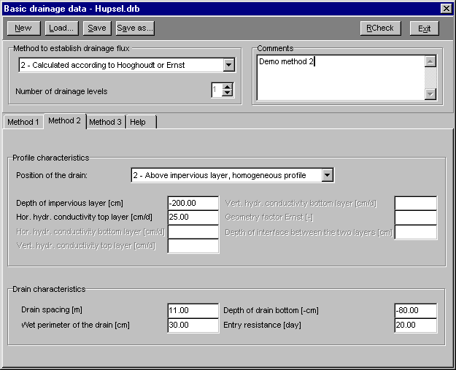
Figure 2.41 Menu option Input/Drainage/basic/ method 2

Method 2: Calculated according to Hooghoudt or Ernst (figure 2.41)
In this option the formulas of Hooghoudt (1940) and Ernst (1956) are used to calculate the groundwater flow to the drainage devices. Five typical drainage situation can be distinguished (figure 2.42) , which demand an increasing number of input parameters:

- Homogeneous soil, drain at impervious layer.
- Homogeneous soil, drain above impervious layer.
- Fine soil layer above coarse soil layer, drain at interface between both layers.
- Fine soil layer above coarse soil layer, drain in coarse soil layer.
- Fine soil layer above coarse soil layer, drain in fine soil layer.

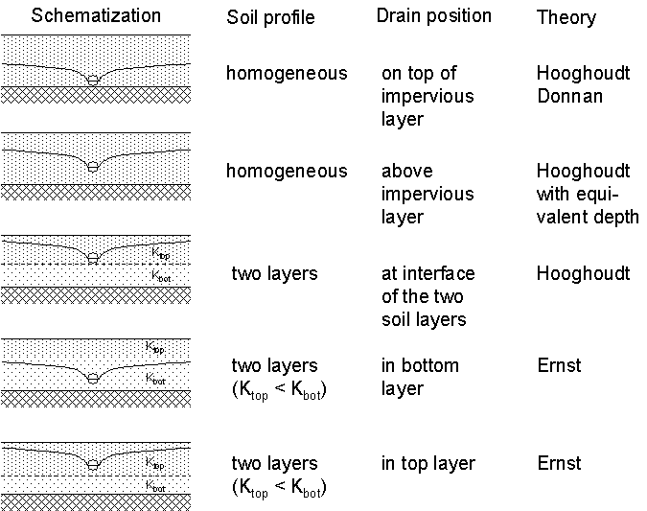
Figure 2.42 Five field drainage situations considered in Swap

The geometry factor of Ernst depends on the ratio of the hydraulic conductivity of the bottom (Khbot) and the top layer (Khtop). Using the relaxation method, Ernst (1962) distinguished the following situations:

- Khbot/Khtop < 0.1 Geometry factor = 1;
- 0.1 < Khbot/Khtop < 50 Geometry factor follows from table 2;
- 50 < Khbot/Khtop Geometry factor = 4.

Table 2: Geometry factor as obtained by the relaxation method (Ernst 1962)
Khbot/  Khtop | Dbot/Dtop
 | 1 | 2 | 4 | 8 | 16 | 32
1 | 2.0 | 3.0 | 5.0 | 9.0 | 15.0 | 30.0
2 | 2.4 | 3.2 | 4.6 | 6.2 | 8.0 | 10.0
3 | 2.6 | 3.3 | 4.5 | 5.5 | 6.8 | 8.0
5 | 2.8 | 3.5 | 4.4 | 4.8 | 5.6 | 6.2
10 | 3.2 | 3.6 | 4.2 | 4.5 | 4.8 | 5.0
20 | 3.6 | 3.7 | 4.0 | 4.2 | 4.4 | 4.6
50 | 3.8 | 4.0 | 4.0 | 4.0 | 4.2 | 4.6

Dbot is thickness of bottom layer; Dtop is thickness of top layer.

The drain characteristics which need to be specified are the same for all 5 different drainage profiles and are self explanatory. The value for the entry resistance can be obtained, analogous to the resistance value of an aquitard, by dividing the wet perimeter of the channel walls by the hydraulic conductivity. If the hydraulic conductivity does not differ substantially from the hydraulic conductivity of the surrounding subsoil, the value of the entry resistance is negligable.

Method 3: Calculated drainage using given drainage/infiltration resistance (figure 2.43)
A linear relationship between the average groundwater level and the drainage or infiltration flux is considered under this option. Up to five different drainage levels can be specified. For each level the user can specify whether drainage or infiltration or both are allowed. If applicable, both the drainage and infiltration resistance need to be specified by the user. The infiltration and drainage resistance might differ because of differences in the groundwater table, local permeability, or preferential flow to the drain.

The drain spacing does not need to be specified if the user has not chosen to distribute the drainage flux vertically (menu option Input/Soil/profile description). Specify the level of the drainage medium bottom. Swap will determine the drainage base by taking the maximum of the drainage medium bottom and the surface water level. If a channel is considered, the water level in the channel as a function of time needs to be specified additionally. A maximum of 366 values can be entered. Both the bottom of the drain or channel and the water level should be specified in cm below soil surface.

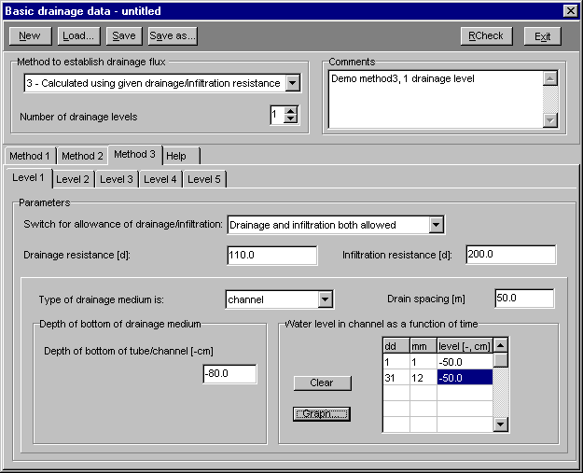
Figure 2.43 Menu option Input/Drainage/basic/ method 3
2.14 Input/Drainage/ extended

Swap allows for two different drainage routines. The basic drainage routine, meant for most field-scale situations (drainage water is ‘lost’) and the extended drainage routine, where the flow of drainage/infiltration water to/from the surface water system and even the surface water system itself is also modelled.

Swap allows for both drainage and infiltration through the same system. Prior to calculating the drainage or infiltration rate, Swap determines whether the flow situation involves drainage, infiltration or neither. No drainage or infiltration will occur if both the groundwater level and the surface water level are below the drainage base. Drainage will occur if the following two conditions are met:
- the groundwater level is higher than the channel bed level;
- the groundwater level is higher than the surface water level.
Infiltration can only occur if the following two conditions are met:
- the surface water level is higher than the channel bed level;
- the surface water level is higher than the groundwater level.
The maximum of the two conditions will be used to calculate the drainage base.

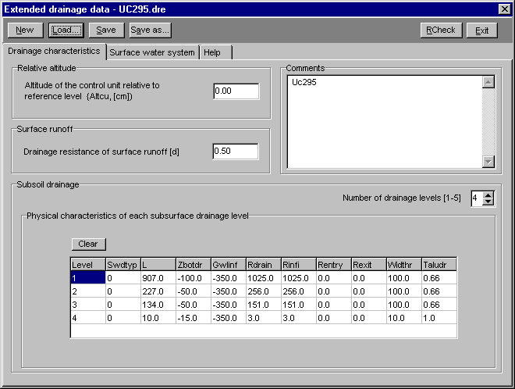
Figure 2.44 Menu option Input/Drainage/extended/ drainage characteristics

The input consists of two parts:
1. The drainage characteristics
2. The surface watersystem

Input/Drainage/extended/ drainage characteristics (figure 2.44)

Altitude
The user should specify the altitude of the control unit (= soil surface) relative to a certain reference level. Of course the user may choose to define the soil surface as reference level by specifying zero for the altitude.

Surface runoff
The user should specify the drainage resistance of the surface runoff. The surface runoff is simulated using a linear relationship similar to the drainage. The runoff depends on the ponding height and a runoff resistance. In general the resistance is small (runoff occurs rather quickly), less than one day. We advise to use a resistance of 0.1 day if dynamic surface runoff simulation is less important. If the dynamics are relevant, a value for the runoff resistance should be derived experimentally.

Subsoil drainage
The drainage system is similar to the resisance method in the basic drainage routine. This means that a linear relationship is considered between the hydraulic head difference and the drainage or infiltration flux. The user should specify the physical parameters for each of the distinguished drainage levels in the system (maximum 5 levels, the first level refers to the deepest channel/drain).

In case of drain tubes (Swdtyp = 1), input for Rentry, Rexit, Widthr and Taludr is not needed. Further explanation of the system can be found in paragraph 9.3 of the Swap manual.

Input/Drainage/extended/ surface water system

The surface water system has the following options:

1. No surface water simulated.
2. Surface water system with a separate primary system:
- Specification of the primary surface water system,
- Specification of the secondary surface water system.
3. Surface water system but no separate primary system:
- Specification of the secondary surface water system.

A primary surface water system belongs to a larger area than the control unit, therefore the water balance of a primary system cannot be calculated . However, through a drainage/ infiltration flux there can be interaction between groundwater in the control unit and the primary surface water system.
A secondary surface water system is fully situated within the control unit. All the water flowing to or from this surface water system is either input to Swap or calculated by Swap. In this way a water balance can be maintained.
Swap does not take into account possible interaction between primary and secondary surface water system by means of control structures: there is no surface water exchange between both systems and water levels in the primary and the secondary system are fully independent of each other. In reality water supply to the secondary system may come from the primary system. Likewise, water discharging across a weir may flow to the primary system.

No surface water system simulated
No further input is needed. This situation can be more easily handled with the basic drainage routine.

Specification of the primary surface water system (figure 2.45)
The surface water level of the primary system (WLP) is defined as function of date (max. 366 data records). Groundwater flow to or from the primary sytem only occurs through subsurface drainage/infiltration flow governed by drainage/infiltration resistance and difference between primary water level and groundwater level.
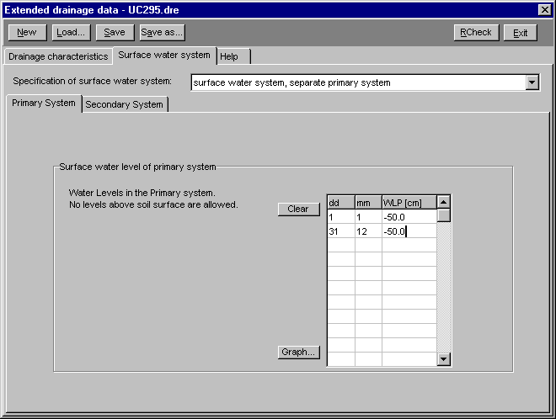
Figure 2.45 Menu option Input/Drainage/extended/ primary system

Specification of the secondary system
Two choices can be made. Either the surface water level is simulated, or the surface water level is read from a table (surface water level is input). Note that choosing one of the options will confine the remaining input requirements.

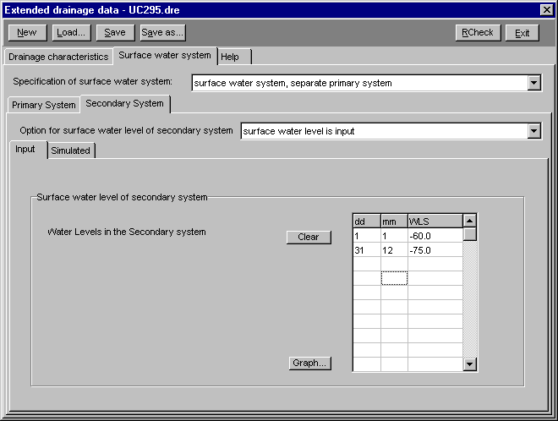
Figure 2.46 Drainage/extended/Surface water system/Secondary system/Input

Surface water level of secondary system is input (figure 2.46)
The surface water level (WLS) is defined as function of date (max. 366 records). Swap will calculate the surface water balance and indicate whether water should be be routed to the control unit (supply) or water should be removed (discharge) in order to maintain this level (see equation 9.9 in the Swap manual).

Surface water level is simulated
This option requires the most comprehensive input. An initial surface water level needs to be specified to start the simulation (figure 2.47). Since an explicit numerical scheme is used to calculate the surface water level, it is possible that the simulation becomes unstable, in which case large oscillations in the surface water level occurs. The user should therefore indicate a criterion for the maximum oscillation of the surface water level. In case of warnings, the user should reduce the maximum time step at menu option Input/Soil/Profile description under parameters numerical scheme. In general a maximum time step equal to 1/50 of the smallest drainage resistance will result in a stable simulation.

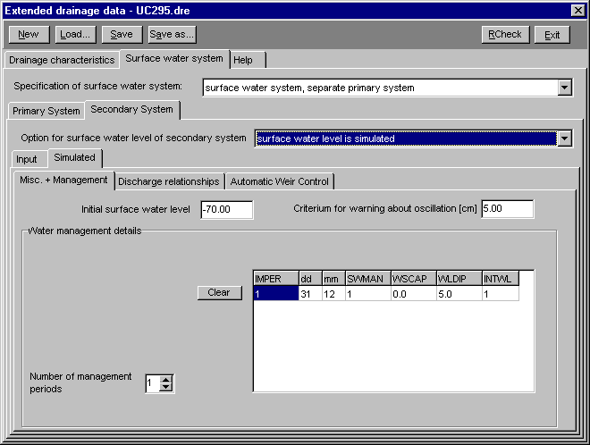
Figure 2.47 Sec. system/Simulated water level/ Miscellaneous and Management

Up to 10 management periods per agricultural year can be identified. For each water management period, the user should specify:

IMPER index of water management period
dd day that period ends
mm month that period ends
SWMAN type of weir control (1 = fixed weir, 2 = automatic weir)
WSCAP surface water supply capacity to the control unit
WLDIP allowed dip of water level below target level before supply starts
INTWL length of water level adjustment period (automatic weir only)

The allowed dip of the surface water level relates to supply situations. In order to avoid quick switches between supply and discharge, the allowed dip is specified. The model does not activate the water supply, as long as the water level remains higher than the target level minus the allowed dip.

Both fixed and automatic weirs can be specified. In either case the input under the tab 'Discharge relationships' should be entered. If automatic weirs are specified, in addition information under tab 'Automatic Weir Control' should be given.

Discharge relationships (figure 2.48)
The discharge relationship can either be described by an exponential relationship or by a table.

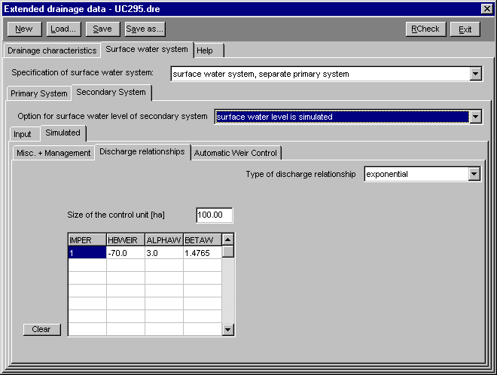
Figure 2.48 Secondary system/Simulated water level/ Discharge relationships

The exponential relationship is determined by the parameters ALPHAW and BETAW. In order to calculate the weir discharge, the surface water level and the crest height of the weir should be known. The crest height should be higher than the deepest channel bottom of the secondary system. Crest height and discharge parameters may differ per management period. Mind the units of the discharge coefficients (see Swap Users Guide Par. 4.14). In order to translate weir discharge in terms of volumes to discharge in terms of surface layer the user should specify the size of the catchment that discharges through the weir (control unit).

In case only measurements are available or the head-discharge relationship cannot be described by an exponential relationship, the user can specify the weir discharge rate as function of surface water level. This table should be specified for each management period . The first value for surface water level should be equal to 100 cm above soil surface level (because the extended drainage routine allows maximum 1 m of ponding layer). The specified weir discharge rate should be zero at a level higher than the deepest channel bottom of the secondary surface water system analogous to the situation with the exponential relationship, where the crest height also always should be higher than the deepest channel bottom.
Automatic weir control (figure 2.49)
Two tables should be filled. In the first table, the user defines the maximum rate with which the target level of an automatic weir is allowed to drop (DROPR, cm/d). This is needed to avoid situations in which the target level reacts abruptly to the prevailing groundwater level. A value of zero may be entered if the user wants to ignore this parameter. The value HDEPTH specifies at which depth the calculated soil water pressure head will be compared to the critical soil water pressure head HCRIT, which is specified in the second table.

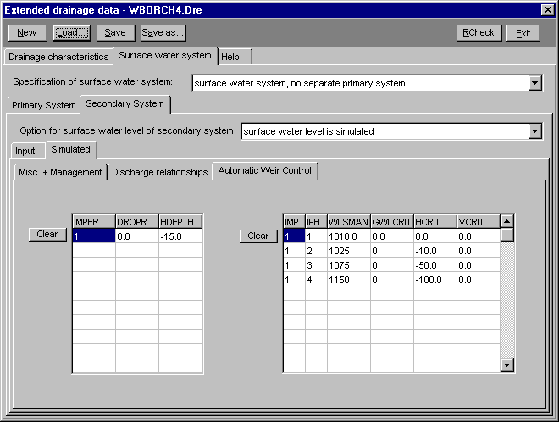
Figure 2.49 Secondary system/Simulated water level/ Automatic Weir Control

The second table consists of sub-tables for each management period IMPER. Per sub-table the user should specify:

IMP index of management period
IPH index of phase number in this management period
WLSMAN surface water level during this phase
GWLCRIT maximum level groundwater level during this phase
HCRIT maximum soil water pressure head at HDEPTH
VCRIT volume that still can be stored in unsaturated zone

The following rules apply:
1) In the first record, corresponding to the lowest surface water level WLSMAN, zero's should be specified for GWLCRIT, HCRIT and VCRIT, as during the first phase the program will set the surface water level equal to WLSMAN.
2) The lowest level of WLSMAN should be still above the deepest channel bottom of the secondary surface water system.
3) The program will select the highest surface water level for which all three criteria (GWLCRIT, HCRIT and VCRIT) are met.
2.15 Input/ Bottom Boundary Condition

The bottom boundary condition in Swap is considered separate from the drainage flux. The drainage flux is defined under the menu option Input/Drainage (extended or basic). The drainage flux applies to 'local' groundwater flow, which is affected by 'local' surface water management. The drainage flux is considered to leave the soil profile horizontally. The bottom boundary condition defined in this menu option, applies to the lower boundary of the soil profile. The specified bottom boundary condition should express the effect of regional groundwater flow. The user is free to include local drainage also in the lower boundary condition and not define it separately in drainage files. However in situations in which the effect of the drainage condition or surface water management on the field scale water and solute balance should be investigated, the local drainage flux needs to be considered separately.

Conditions
Swap allows 8 different bottom boundary conditions:
- Groundwater level is given
- Regional bottom flux is given
- Flux from deep aquifer is calculated
- Upward flux calculated as a function of groundwater
- Pressure head of bottom compartment is given
- Zero flux at the bottom of the profile
- Free drainage at the bottom of the profile
- Lysimeter with free drainage

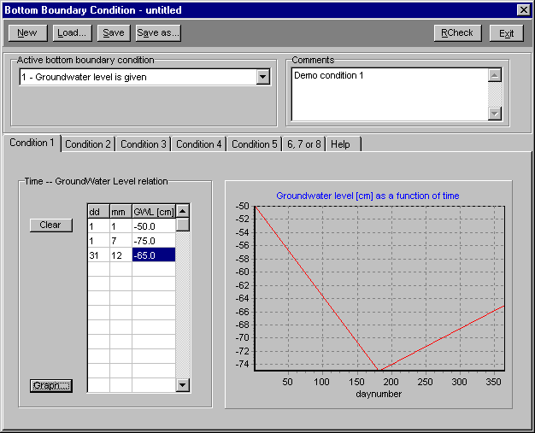
Figure 2.50 Menu option Input/Bottom boundary/ Condition 1

1) Groundwater level is given (figure 2.50)
Up to 366 records can be entered to describe the ground water level GWL as a function of time. Similar to other data that are given as function of time, Swap will linearly interpolate between the data pairs.

2) Regional bottom flux is given (figure 2.51)
The user can either use a table to specify the regional bottom flux, or use a sine function to generate a regional bottom flux. If a sinusoidal bottom flux is defined the user should provide mean value, amplitude and the day number at which the maximum of the sine wave occurs. Positive values for the function indicate an upward flux, while negative values correspond to a downward flux.

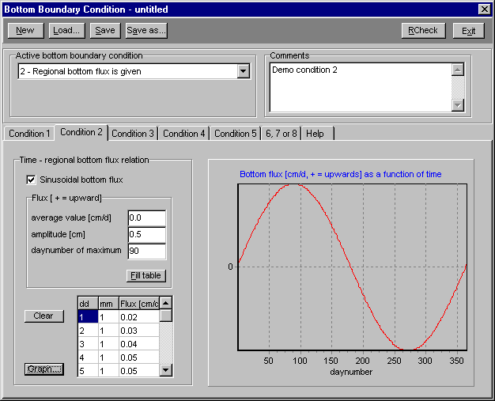
Figure 2.51: Menu option Input/Bottom boundary/ Condition 2

3) Flux from a deep aquifer is calculated (figure 2.52).
In this case the bottom flux is calculated from an aquifer below the phreatic aquifer. Since the shape of the phreatic groundwater is relevant for the calculation of the average groundwater level, the user should specify a shape factor and the mean drainage distance. Possible values for the shape factor are 0.66 (parabolic), 0.64 (sinusoidal), 0.79 (elliptic) and 1.00 (flat, no drains). The bottom flux is calculated by dividing the hydraulic head difference between groundwater and semi-confined aquifer by the resistance of the semi-confining layer (see Eq. 2.23 in the Swap manual).

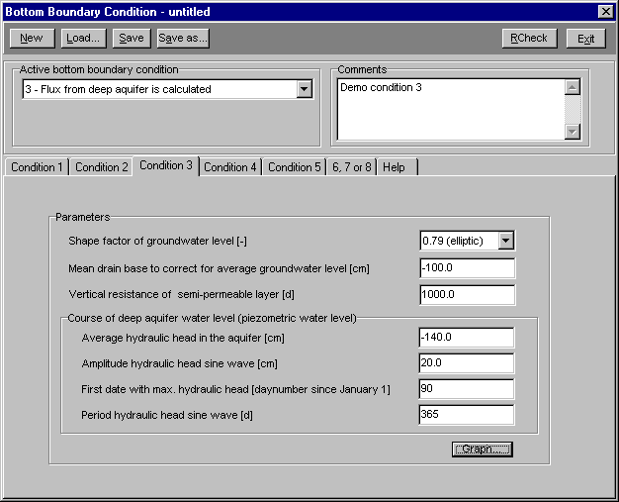
Figure 2.52 Menu option Input/Bottom boundary/ Condition 3
The user should also specify the parameters defining the sine wave in the aquifer (similar to condition 2):
- the average hydraulic head in the aquifer
- the daynumber at which the maximum occurs
- the amplitude of the sine wave

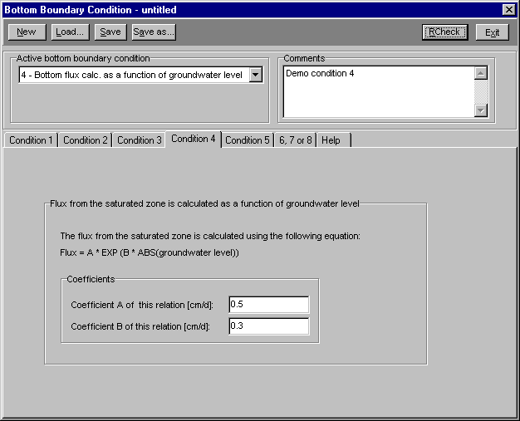
Figure 2.53 Menu option Input/Bottom boundary/ Condition 4

4) Bottom flux calculated as a function of groundwater (figure 2.53)
The exponential relationship was developed for deep sandy areas in the Netherlands, so care should be taken when this condition is used elsewhere. The user should specify the coefficients in the exponential relationship. The Swap manual refers to Massop and De Wit (1994) and Ernst and Feddes (1979) for examples of these relationships.

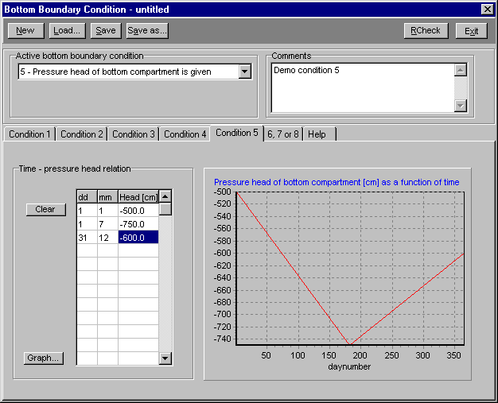
Figure 2.54 Menu option Input/Bottom boundary/ Condition 5
5) Pressure head of the bottom compartment is given (figure 2.54)
In literature this option is called the Dirichlet condition. The user can specify up to 366 pressure heads in the table.

6) Zero flux at the bottom of the profile (figure 2.55)
This condition occurs when a impermeable layer exists at the bottom of the profile. No further data are needed for this boundary condition.

7) Free drainage at the bottom of the soil profile (figure 2.55)
This condition applies to soil profiles with deep groundwater levels, for which unit gradient of hydraulic head can be assumed at the bottom boundary. The accuracy of the simulated soil moisture profiles depend on the accuracy of the hydraulic conductivity function in the lower soil layers. Also with this option no further data are needed.

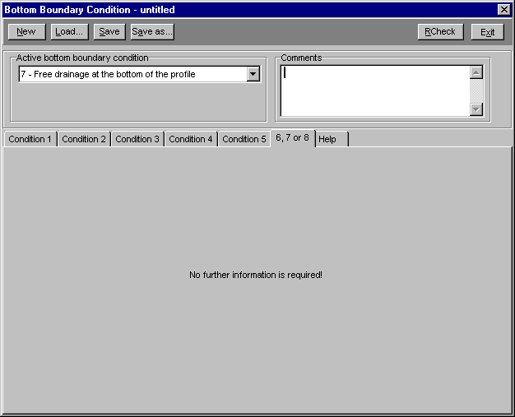
Figure 2.55 Menu option Input/Bottom boundary/ Condition 6,7 & 8

8) Lysimeter with free outflow (figure 2.55)
This option can be used in case of free outflow at a soil-air is to be simulated. Drainage will only occur if the pressure head in the bottom compartment increases until above zero. If the pressure head is negative, a no-flux boundary applies. For instance in case of lysimeter experiments in which the soil column has free outflow in the air, this boundary condition applies. No further data are needed for this boundary condition.
2.16 Input/ Solute transport

Input data for this option only need to be specified if the user has selected simulation of solute transport (menu option Input/ Key). Solute transport is simulated with the convection-dispersion equation including adsorption and decomposition processes in case of reactive solutes. Swap is limited to transport of salts, pesticides and other solutes that can be described with relatively simple kinetics. A main advantage of incorporating solute transport in a hydrological model like Swap is that interactions between water flow, solute transport and plant growthare accounted for on a short time step basis. Fpr instance the reduction of root water uptake due to high salinity concentrations, orthe effects of preferential flow on solute transport, require simultaneous solution of the water flow and solute transport equations. Also provisions for coupling on distance are provided. Detailed analysis of pesticide transport can be performed with the combination SWAP-PESTLA (recently rebaptized to Pearl), while detailed nitrate transport can be performed with the combination SWAP-ANIMO.

Input/Solute transport/ Parameters 1 (figure 2.56)

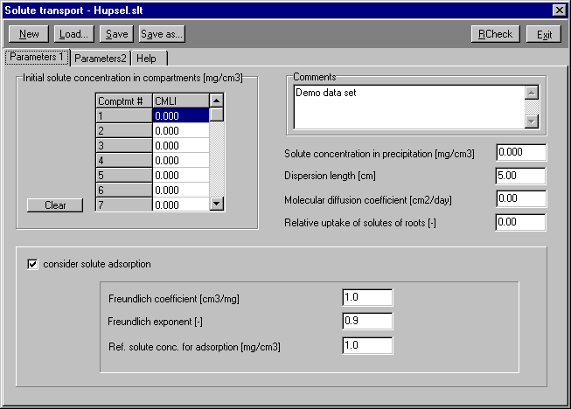
Figure 2.56 Menu option Input/Solute transport/ Parameters 1

Basic information
The user should specify:
- the initial solute concentrations
- the solute concentration in the precipitation
- the dispersion length; Jury et al. (1991) indicated a value between 0.5 and 2 cm for packed laboratory columns and a value between 5-20 cm for field conditions
- the molecular diffusion coefficient; this coefficient is in the order of 0.012 cm2/day; in many field situations solute dispersion dominates solute diffusion;
- the relative solute uptake factor K_{r} for the roots; if K_{r} > 1, solutes are taken up at a higher rate than would follow from the product soil water uptake times solute concentration.

Solute adsorption
In case of solute adsorption, solute movement is retarded because part of the solute is adsorbed to the soil particles. The user should supply the following parameters:
- Freundlich coefficient ; in case of linear adsorption this parameter is equal to the slope of the adsorption-desorption curve;
- Freundlich exponent; in case of linear adsorption the user should specify a value of 1.0, otherwise non-linear adsorption applies;
- reference value of the solute concentration, which function is to make the Freundlich exponent dimensionless.
Input/Solute transport/ Parameters 2 (figure 2.57)

Solute decomposition
Solute decomposition is calculated from a potential solute decomposition rate which applies to soil from the plow layer at 20 C and at a suction h = -100 cm. The potential decomposition rate is reduced by the factors temperature, dryness and increasing soil depth.
Therefore the user should specify (see Swap manual Par. 3.3):
- the potential decomposition rate
- the temperature parameter used to calculate the reduction factor due to temperature decrease;
- the minimum water content for potential decomposition
- exponent of the relation proposed by Walker (1974) to describe reduction of decomposition due to dryness
- decomposition reduction factors due to increasing depth for each soil layer

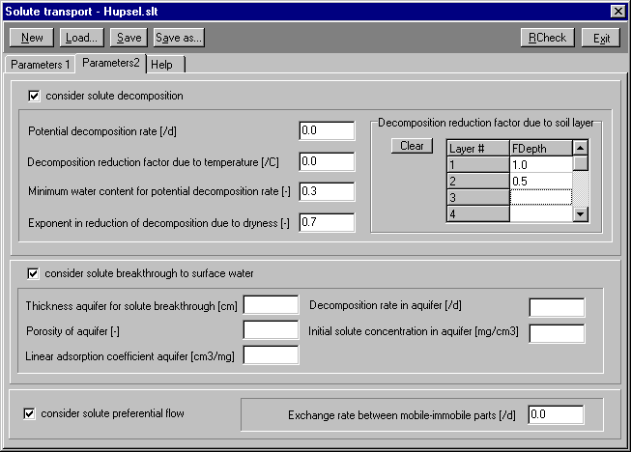
Figure 2.57 Menu option Input/Solute transport/ Parameters 2

Solute breakthrough to surface water
In case no solute leaching to surface water needs to be simulated, the user only needs to enter the solute concentration in the aquifer, which will be used in case of upward flow at the profile lower boundary.
Swap allows to calculate the transport of the solute from the soil surface to the surface water. In the unsaturated zone the convection-dispersion will be solved, while solute transport in the saturated zone is described by a mixed reservoir. In the saturated zone only linear adsorption and first order decomposition can be simulated. The user should specify the following parameters:
- thickness of the aquifer for solute breakthrough
- porosity of the aquifer
- linear adsorption coefficient for the aquifer
- decomposition rate in the aquifer
- initial solute concentration in the aquifer

Preferential solute transport
Preferential solute by unstable wetting fronts, for instance in case of water repellent soils, is specified in this section. The soil fractions with mobile water have already been specified at menu option Input/Soil/Profile description, here only the solute exchange rate between the mobile and immobile parts should be specified.
2.17 Input/ Heat transport

Input for this option only needs to be provided if the user has selected simulation of heat transport (menu option Input/ Key).

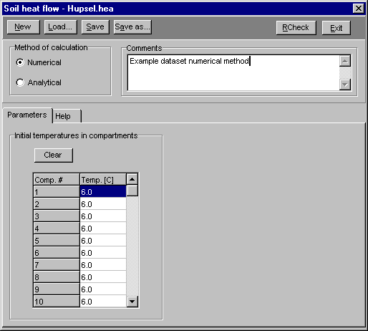
Figure 2.58 Menu option Input/Heat transport/ Numerical/ Method

Heat transport in Swap can be simulated by an analytical or numerical method.

Numerical (figure 2.58)
The initial conditions should be entered in the table 'initial temperatures in the compartments'. Swap uses the average daily temperature from the daily meteo file as a top boundary condition and assumes a zero flux boundary at the bottom compartment. The soil heat capacity and the thermal conductivity are calculated by Swap according to De Vries (1963), using the soil texture data as provided at menu option Input/key/profile description and the actual water content.

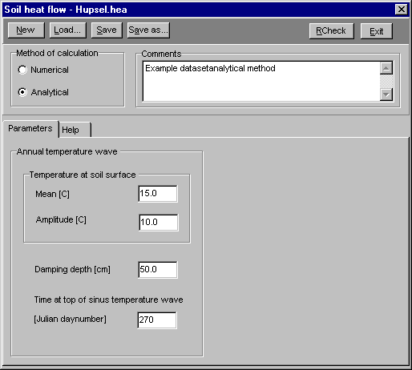
Figure 2.59 Menu option Input/Heat transport/ Analytical /Method

Analytical (figure 2.59)
In the analytical method the soil thermal diffusivity and the soil volumetric heat capacity are assumed to be constant. In that case the partial differential heat equation can analytically be solved assuming a sinusoidal variation of the temperature through the year.

The user should specify the mean value, amplitude and the daynumber with the maximum soil surface temperature. Additionally the user should specify the damping depth, which is a function of the heat diffusivity (see Eq. 4.8 in Par. 4.2 of the Swap manual).
3 The Run menu

The run menu may contain a variable number of items (figure 3.1).

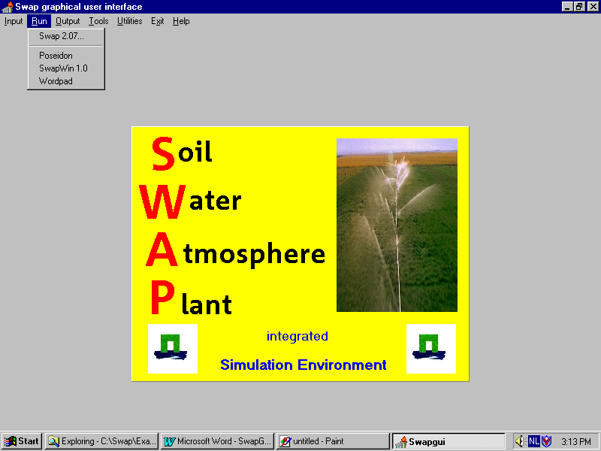
Figure 3.1 The run menu contains three user installed items

The option to run Swap is always available. Other programs may be installed to be launched from the run menu. The procedure to follow will be explained in chapter 6 (Utilities menu).

3.1 Run Swap as a console application

A simulation run with Swap is executed within a DOS-box (figure 3.2). The only information required is the name of the relevant key file.

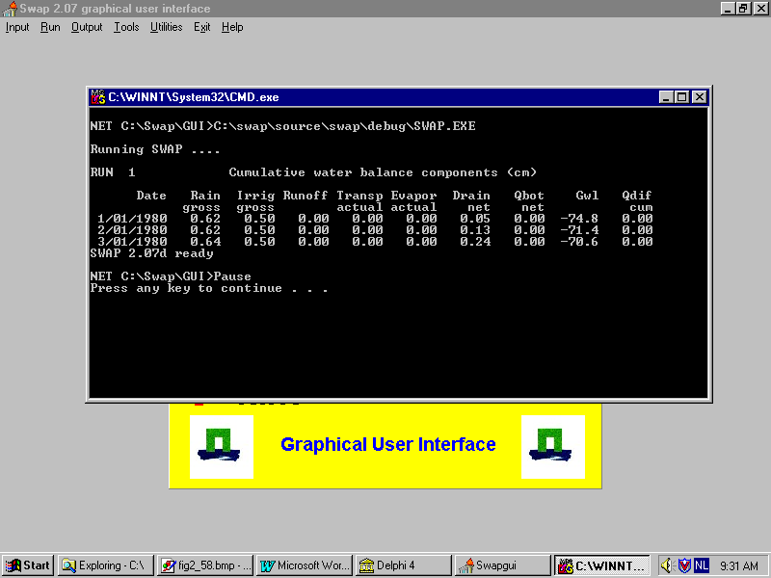
Figure 3.2 Swap on the run

During a simulation some of the water balance components are displayed on the screen to see the simulation progress and provide a first evaluation..
After a simulation run a message appears with information whether the run with Swap has normally terminated or was aborted prematurely due to some error. In the latter case the log file (SWAP207?.log) in the directory where the Swap executable resides may be examined.

4 The Output menu

The output menu contains three items:
- Graphs
- Balances
- 3D Vap viewer

4.1 Output/ Graphs

The output visualization part of Swap for Windows is able to display Swap output data in graphical form for a period of up to 10 years. In case of a longer simulation period, a display period within the simulation period must be selected.

Three types of graphs can be produced:

X-Depth graphs
For each output day soil water pressure head, soil moisture content, soil temperature, solute concentration, soil water flux, or solute flux, can be depicted as function of depth below soil surface. Two simulation runs can be compared, i.e. the results of two runs can be displayed simultaneously.

X-Y graphs, time series
One or two output variables, either from one or from two simulation runs can be depicted as a function of time.

X-Y scatter diagrams with linear regression
This graph depicts variable Y as function of variable X (one simulation only). At this option linear regression analysis between x and y can be applied.

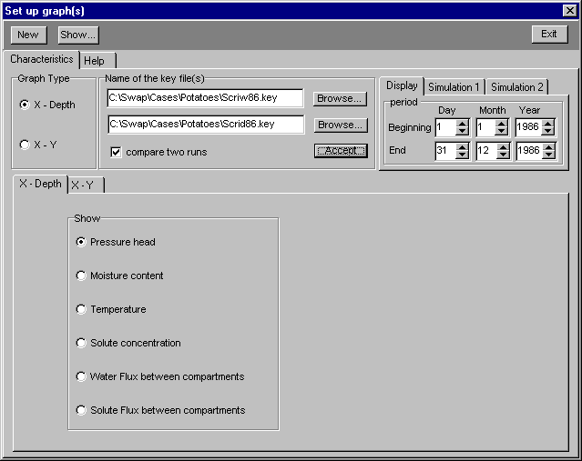
Figure 4.1 Menu option Output/ Graphs/ X-Depth plot

X-Depth graph (figure 4.1)

The form builds up gradually while carrying out the following steps:

- Check option 'X-Depth’ at label 'Graph Type'.
- Specify the name of the first key file, possibly using the browse facility. If the results of two simulation runs must be displayed simultaneously: check 'compare two runs' and specify the name of the second key file. Note that it is allowed to specify the same key file two times, which is useful to show simultaneously graphs for different output days. Click the 'Accept' button. From now on it will be assumed that two runs have been selected.
- Specify the display period. As a reminder the simulation periods are indicated on pages 'Simulation 1' and 'Simulation 2' respectively. The display period must be covered by both simulation periods and may not exceed 10 years.
- Select graph type: pressure head, moisture content, temperature, solute concentration, water flux or solute flux and click the 'Show...' button at the top.
- A window appears with several panes showing one or two graphs with their control buttons (figure 4.2): the 'Previous', 'Next' and 'FastFW' buttons allow navigation through a sequence of graphs (one for each output day). Fast forward speed is regulated by the 'Delay' period. Clicking 'Reset' shows the first graph in the sequence.

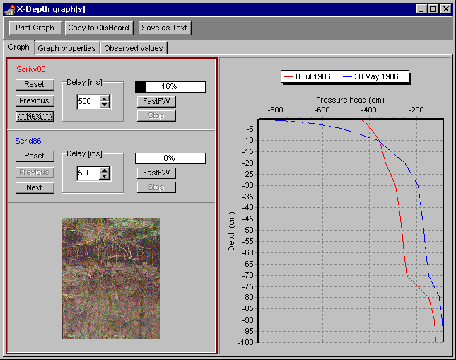
Figure 4.2: Example of an default X-depth plot

Customizing the graph
On page ‘Graph properties’ titles, axis scales and annotations may be redefined (figure 4.3).
After clicking the ‘Apply’ button the modifications are applied to the graph(s) (figure 4.4)

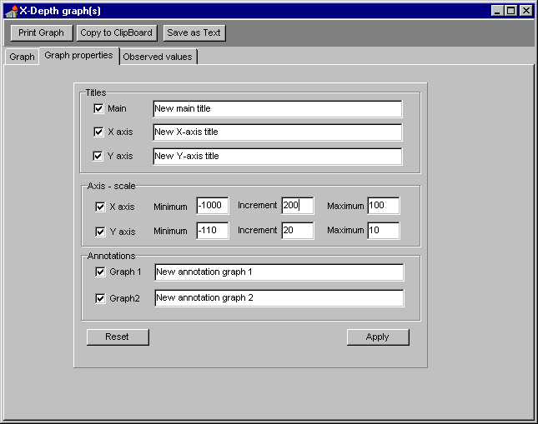
Figure 4.3 Redefinition of titles, scales and annotations

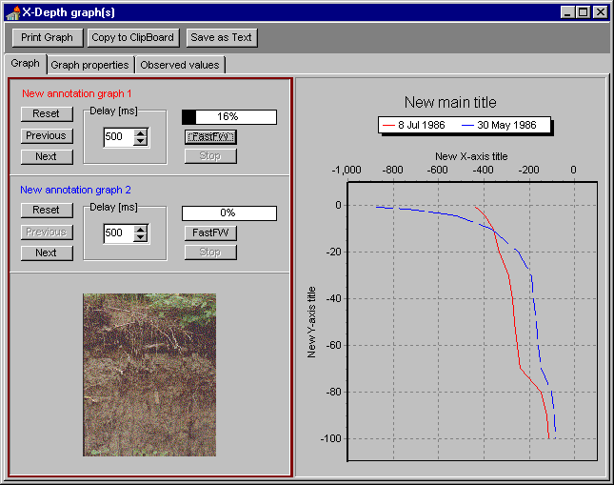
Figure 4.4 The graph with applied customizations
Adding observed values
On page ‘Observed values’ combinations of depth and value may be entered or loaded from file, where the file should be a simple text file containing two colums delimited with blanks (figure 4.5). After clicking the ‘Apply’ button the observed values are added to the graph(s) (figure 4.6).

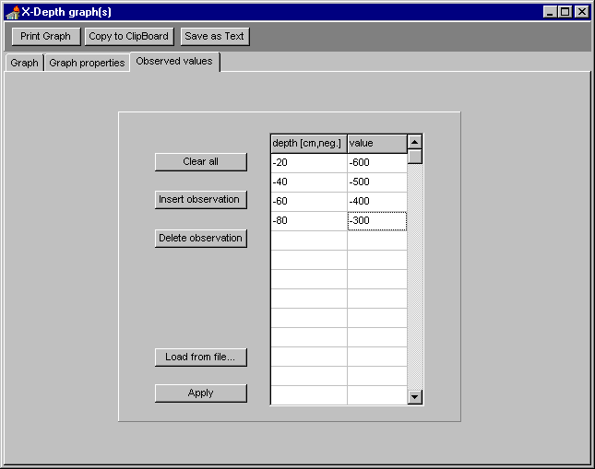
Figure 4.5 Specification of observed values

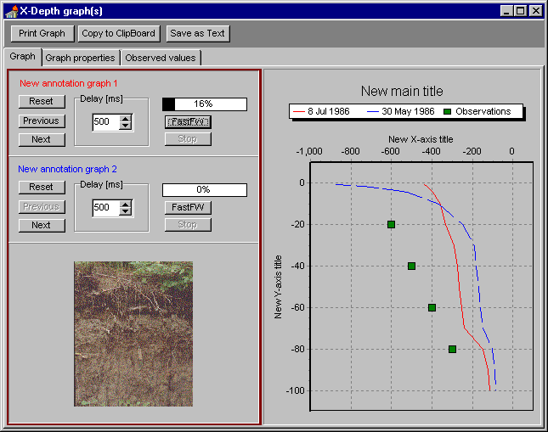
Figure 4.6 Final graphs: customized and including measured values
X-Y graph, time series (figure 4.7)

The form builds up gradually while carrying out the next steps:

- Select option ‘X-Y’ from radiogroup ‘Graph Type’.
- Specify the name of the first key file, possibly using the browse facility. If the results of two runs must be displayed simultaneously, select ‘compare two runs’ and specify the name of the second key file. This time it does not make sense to specify the same key file two times. Click the ‘Accept’ button.
- Specify the display period. As a reminder the simulation periods are indicated on pages ‘Simulation 1’ and ‘Simulation 2’ (in case of two runs) respectively. In case of two runs the display period must be covered by both simulation periods. The display period is limited to 10 years.
- Select option for X-axis by clicking the relevant ‘Change…’ button. Select option ‘Date’ from page Miscellaneous and click ‘Accept’.
- Select option for the left Y-axis. All options are supported except 'Date'. Click 'Accept'. The selected option for Y1 is valid for either one or both simulation runs.
- Select option for the right Y-axis. All options except 'Date' are allowed. Click 'Accept'. The selected option for Y2 is valid for either one or both simulation runs.
- Clicking 'Show...' reveals a window with the desired graphs (figure 4.8).

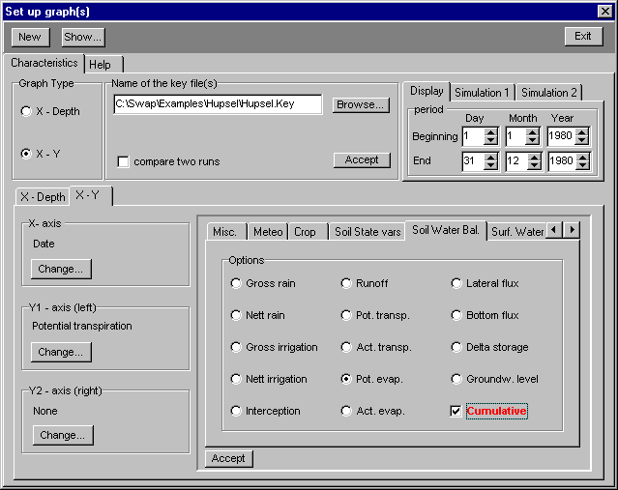
Figure 4.7 Set up of an X-Y graph. For the left Y-axis (cumulative) potential transpiration has been selected and currently the option cumulative potential evaporation has been selected for the right Y-axis. Clicking the ‘Accept’ button will confirm this choice in the ‘Y2 – axis (right)’ group box wich at this moment still shows ‘None’.
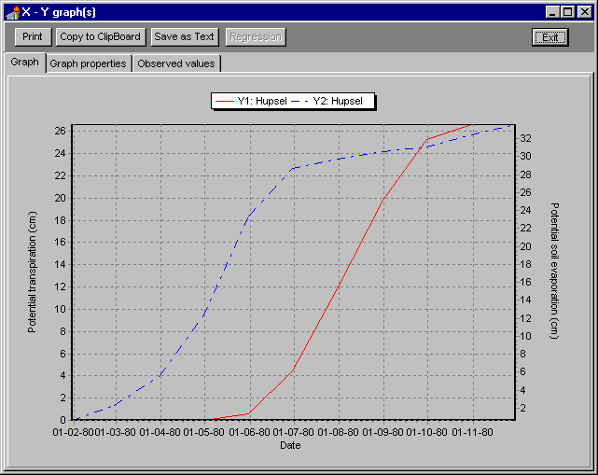
Figure 4.8 Example of a default X-Y plot

Customizing the graph
On page ‘Graph properties’ titles, axis-scales and legends may be redefined (figure 4.9).

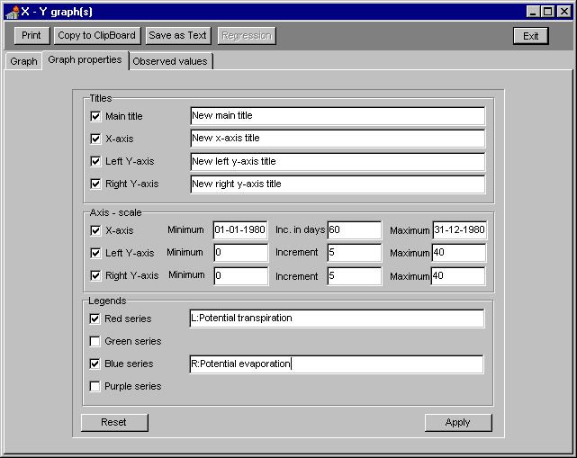
Figure 4.9 Redefinition of titles, scales and legend descriptions

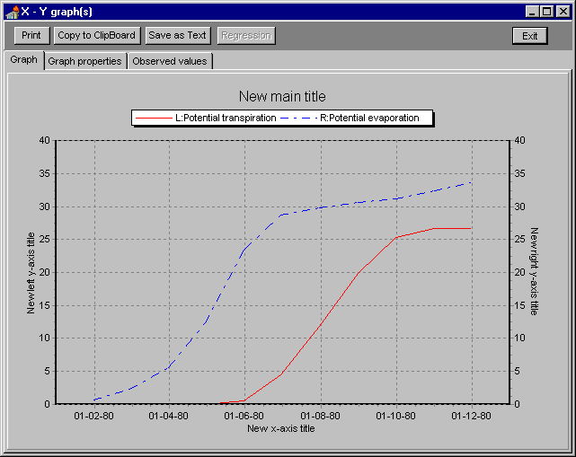
Figure 4.10 Graph 4.8 but this time with applied modifications

Adding observed values
On page ‘Observed values’ a time series of values for one parameter may be entered or loaded from file, where the file should be a simple text file containing 4 columns delimited with blanks (figure 4.11). After clicking the ‘Apply button the observed values are added to the graph (figure 4.12).

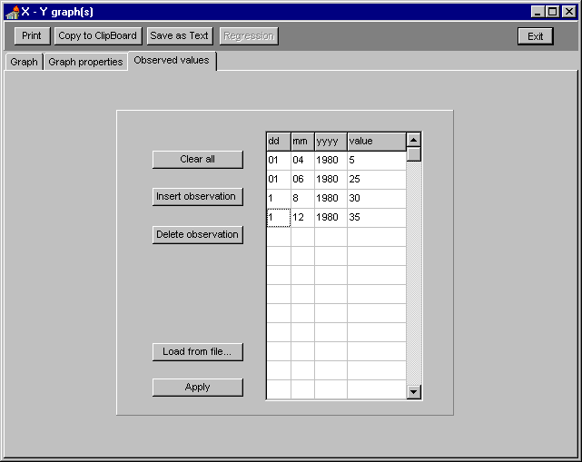
Figure 4.11 Specification of observed values
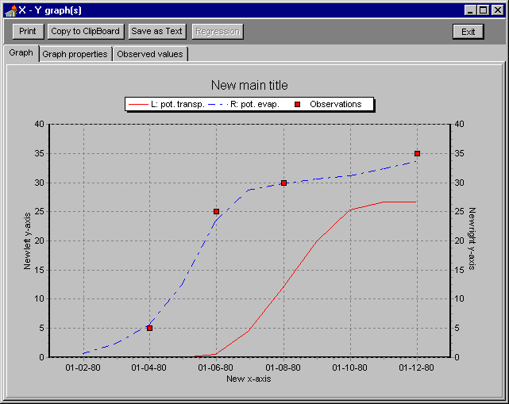
Figure 4.12 Final graphs : customized and including observed values

X-Y scatter diagram with linear regression (figure 4.13)

Making an X-Y scatter diagram is very similar to making an X-Y graph, however it is not allowed to compare two runs and the selected option for the X-axis must be different from ‘Date’. Clicking ‘Show…’ reveals a window with the desired scatter diagram.
Linear regression is carried out after clicking the ‘Regression’ button.

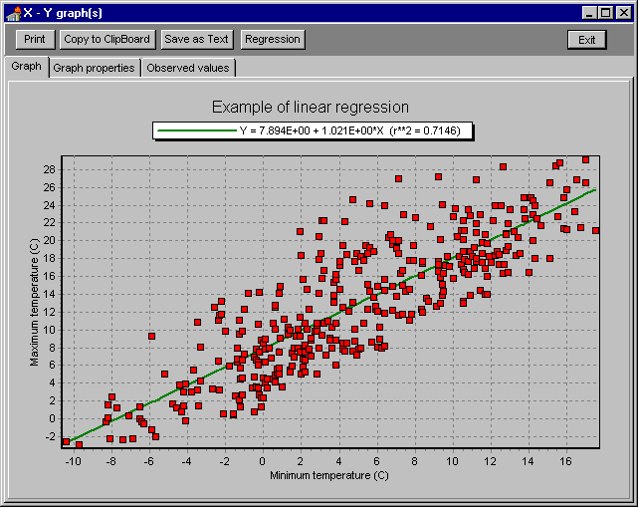
Figure 4.13 Example of an X-Y scatter diagram with linear regression
4.2 Output/ Balances

For each subrun Swap produces an output file with water and, if relevant, solute balance components (.BAL file). The output/balances option offers a simple tool to simultaneously examine two such files in text form or in graphical form. The example case concerns a simulation run over two years (1980 and 1981) where in the first year a pesticide has been applied.

On page Setup one or two key files must be specified (possibly using the ‘Browse’ buttons), depending on whether the ‘compare two runs’ checkbox has been checked or not. In the example case the aim is to display two subruns from one simulation run. In that case both key files should have the same name. From both drop down lists the revelant subruns have been selected (result80 respectively result81) .
After clicking the ‘Apply’ button Result80.BAL and Result81.BAL are displayed just as they are: simple text files (figure 4.14), and the numbers might be compared directly.

On page Graphs Water Balance the water balance components are displayed as a bargraph (figure 4.15). Note that 1981 is a much drier year than 1980.

On page Graphs Solute Balance the solute balance components are displayed as a bargraph (figure 4.16). Note that in 1981 lateral outflow of solute is larger than in application year 1980.

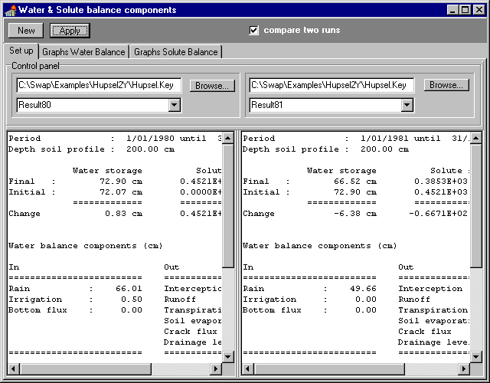
Figure 4.14 Water and solute balance components of the two example subruns as text

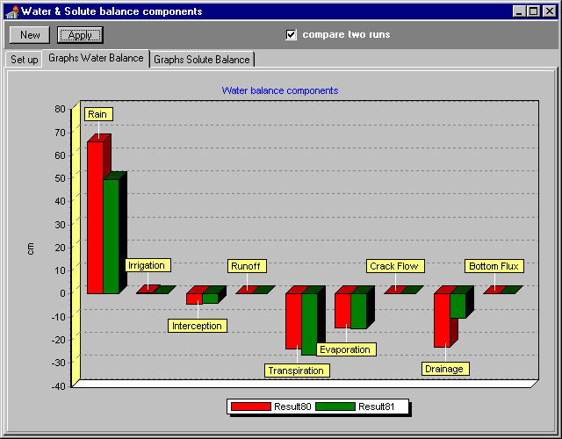

Figure 4.15 Water balance components of the two example subruns as bargraph

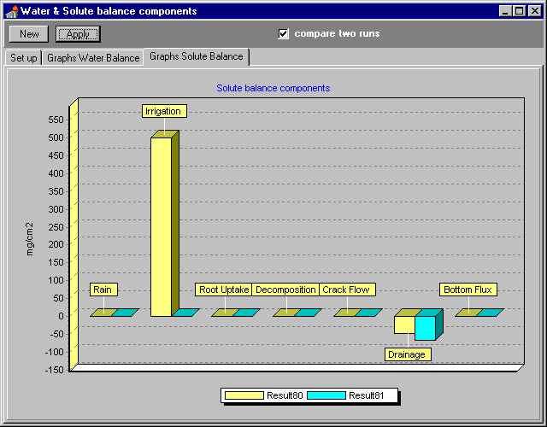

Figure 4.16 Solute balance components of the two example subruns as bargraph

4.3 Output/ 3D Vap viewer

If selected, Swap produces soil profile output files (.Vap files), containing moisture content, pressure head, solute concentration , soil temperature, soil water fluxes and solute fluxes as a function of depth. This output is produced for each output day.

With the 3D Vap viewer it is possible to simultaneously display pressure head, moisture content, temperature and solute concentration information from up to three .Vap files both as 2D or 3D graphs. Even used with only one simulation this is an interesting output option. For instance in case of upward seepage you might examine with a tracer whether groundwater reaches the root zone or the viewer may show how long it takes for a contamination to travel from the soil surface to the groundwater etc.

The example case concerns three simulation runs over the same period of three years (1988, 1989 and 1990). In the first run rainwater has been given a certain tracer concentration , in the second run incoming lateral water has been given a certain tracer concentration and in the third run seepage water through the bottom of the soil profile has been given a certain tracer concentration.

Graphical output from the first run is colored red (R), output from the second run is colored green (G) and output from the third run is colored blue (B). In addition to output from the individual runs (Graph1, Graph2 and Graph 3) there is a Composite graph showing the combined effect of the three solute fluxes in true RGB.

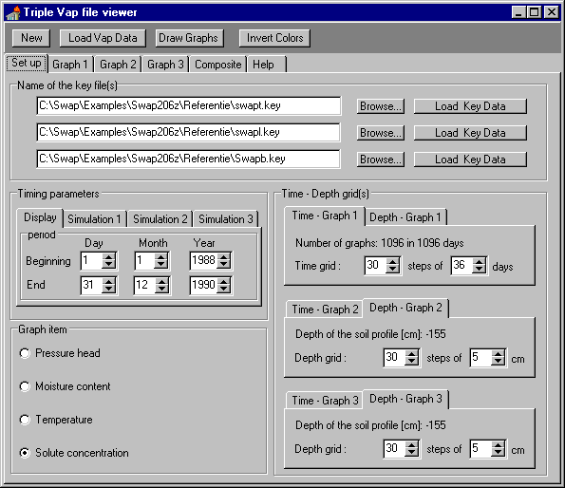
Figure 4.17 3D Vap file viewer, page Setup

Page Set up (figure 4.17)
The form builds up gradually while carrying out the next steps:
- Specify one or more key files, possibly by using the ‘Browse’ button(s).
- For each valid key file click the ‘Load Key Data’ button.
- Specify the Display period, which must be covered by all simulations, using as a reminder the indicated separate Simulation periods.
- Click the ‘Load Vap Data’ button.
- Specify Graph item.
- Specify (equidistant) steps in the Time – Depth continuum .

After clicking the ‘Draw Graphs’ button, for each specified key file one graph is drawn together with the Composite graph.

Page Graph 1 Graph 2 & Graph 3 (figure 4.18)
In figure 4.18 a contour plot (2D) of the tracer concentration as a function of time (horizontal axis) and depth (vertical axis) is displayed . The tracer comes with the rain water.
Note that during the summer when there is a rainfall deficit, the contour lines bend upward.
At the end of the three year period the tracer has reached a depth of 90 cm (18*5).

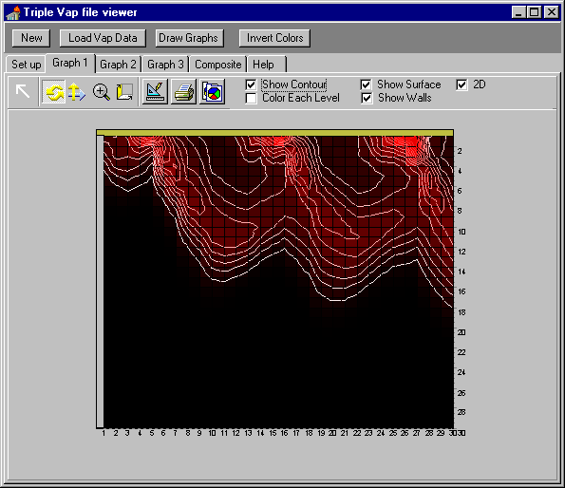

Figure 4.18 Contour plot of salt concentration as a function of time (X-axis) and depth (Y-axis)

Page Composite (figure 4.19)
In figure 4.19 the combined effect of the three tracer fluxes from different origin has been depicted as a surface plot (3D).
Using items on the tool bar it is possible to translate or rotate the graph, to zoom in or out, etc. Also it is possible to invert RGB values by clicking the ‘Invert Colors/RGB’ button

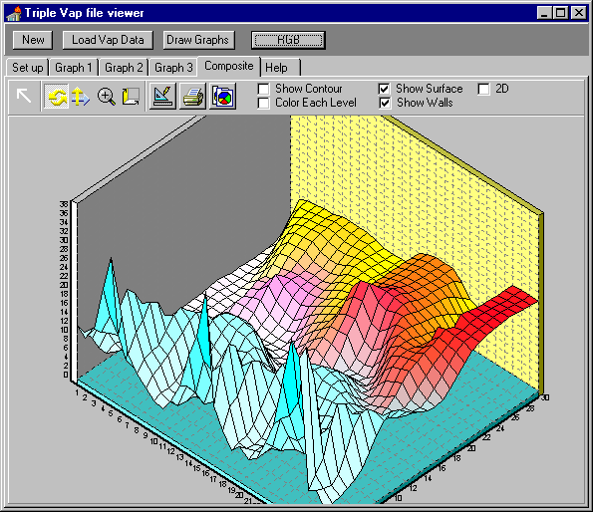

Figure 4.19 Surface plot showing tracer concentration (Y-axis) as afunction of time (X-axis) and depth (Z-axis)

5 The Tools menu

Swap for Windows is supplied with a simple text editor to edit and print Swap input and output files. These files are described in detail by Kroes et al. (1998). Figure 5.1 shows the editor loaded with an output file from the detailed grass model.
The editor has a File menu equipped with standard options (New, Open, Save, Save as, Print, Printer setup and Exit), an Edit menu with standard options (Cut, Copy, Paste, Delete, Select all, Word wrap and Set font) and a Search menu with a useful replace option that allows automatic replacement of tab or slash characters with a space character.

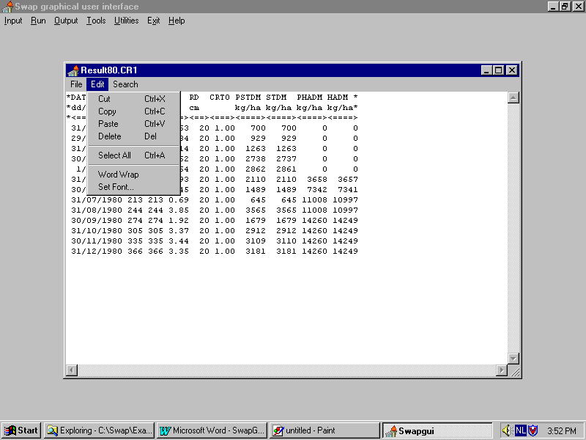
Figure 5.1 Simple text editor under the Tools menu

In addition to the graphs produced by SwapGui, the user may analyse the simulation results by viewing the various Ascii output files that are generated by Swap. Depending on the choices made (see section Input/Key/Run options), the following files are produced for each sub-run:
- Water balance (*.WBA)
- Solute balance (*.SBA)
- Water and solute balance overview (*.BAL)
- Soil moisture-, solute- and temperature profiles (*.VAP)
- Interaction with surface water (Extended Drainage) (*.DRF, *.SWB, *.MAN)
- Scheduled irrigations (*.SC1, *.SC2, *.SC3).
- Crop growth results (*.CR1, *.CR2, *.CR3).

Formatted and unformatted (binary) export files can be generated with data that cover the entire simulation period (*.AFO/*.PFO, .AUN/*.PUN, *.ATE, *.AIR). These export files can be directly used as input for pesticide and nutrient models like Pestla (Van den Berg and Boesten, 1998), recently rebaptized to Pearl and Animo (Kroes and Roelsma, 1998).

6 The Utilities menu

6.1 Utilities/Check Input Files

As indicated in section 2.1 Swap needs various input files. Some files are always required, some become compulsory depending on the setting of run control switches, and some are always optional. In addition to table 2.1 the utility ‘check presence of input files’ is meant to help the user with the preparation of a complete set of input files.

First the name of the key file must be specified, possibly by clicking the ‘Browse’ button.
If this file does exist, clicking the green ‘Accept’ button starts the quest for input files.

Expected input files (figure 6.1)
All input files expected by Swap because they are compulsory or because their names have been specified (although the category is optional) are listed in a checklist. Sometimes in case of an input error, a file name is unknown and will be displayed as ’???’ followed by a number and the proper extension. For instance if a soil profile contains two layers and only one .Sol file has been specified in the .SWA file, the file ???2.Sol will be added to the list. The list in figure 6.1 belongs to a Swap run over two years. The name of the compulsory file with bottom boundary conditions for the first year and the compulsory (because drainage had been selected) file with drainage data for the second year were not specified in the key file. All listed files that actually exist in the project directory will be checked, so it is easy to see what (kind of) files are missing because they remain unchecked. The figure shows that files with detailed rainfall data were not found while SWRAI had been switched on in Hupsel.Key.

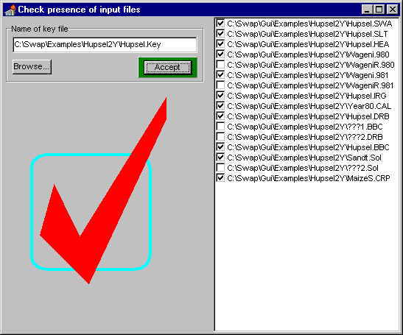

Figure 6.1 Expected input files

6.2 Utilities/Set & remove user programs

Windows programs can be installed in the run menu, so that they may be executed without leaving SwapGui. Although any Windows application can be installed, it makes sense only if the application has some relation with the graphical user interface. Some examples of these so called add-ins have been presented in Appendix A: a program to analyse Swap output and an example of an implementation of Swap in an object oriented language.

How to set and remove add-ins

Setting and removing user-defined programs is straightforward (figure 6.2).

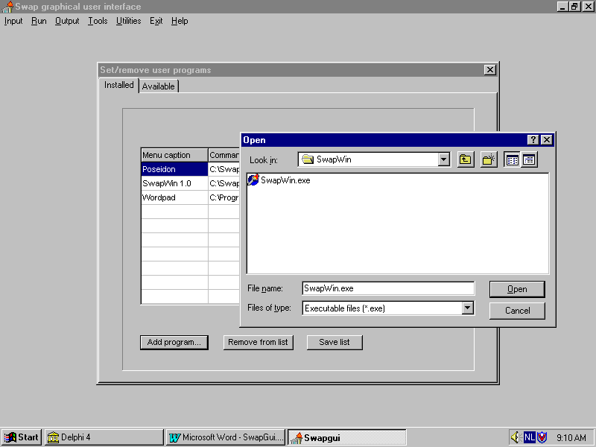

Figure 6.2 Procedure to install an add-in program

Clicking the ‘Add program…’ button opens a open file dialog. The selected Windows application will be added to the list . Next the name for the menu item must be specified and the list must be saved (to SwapGui.Plg). Items in SwapGui.Plg (if in the same directory as SwapGui.Exe) will be added to the run menu each time SwapGui is started.

To remove a menu item, select the item and click ‘Remove from list’. The modification will be permanent after saving the list.

References

Allen, R.G., M. Smith, A. Perrier and L.S. Pereira. 1994. An update for the definition of reference evapotranspiration. I.C.I.D. bulletin, 43(1994) 2, 1-34 and 35-92.

Berg, F. van den, and J.J.T.I Boesten, 1998. Pestla 3.2. Description, User’s Guide and Installation, Technical Document 43, DLO Winand Staring Centre, Wageningen.

Berman, M.B., 1971. Generating gamma distributed variates for computer simulation models. Rand Copr. Pub. R-641-PR, Santa Monica , Ca.

Braden, H., 1985. Ein Energyhaushalts- und Verdunstungsmodell fur Wasser und Stoffhaushaltungsuntersuchungen landwirtschaftlich genutzter Einzugsgebiete. Mitteilungen Deutsche Bodenkundliche Geselschaft, 42, 294-299.

De Bruin, H.A.R., 1987. From Penman to Makking. In: J.C. Hooghart (Ed.), Evaporation and Weather. TNO Proceedings and Information, Nr. 39, p. 5-31.

Ernst, L.F., 1956. Calculation of the steady flow of groundwater in vertical cross-sections. Netherlands Journal of Agricultural Science 4, 126-131.

Ernst, L.F., 1962. Groundwater flow in the saturated zone and its calculation when parallel open conduits are present. Thesis (Dutch with English summary), University of Utrecht, 189 pp.

Ernst, L.F., and R.A. Feddes, 1979. Invloed van grondwateronttrekking voor beregening en drinkwater op de grondwaterstand. Report 1116, ICW (currently Winand Staring Centre), Wageningen, The Netherlands.

Feddes, R.A., P.J. Kowalik and H. Zaradny, 1978. Simulation of field water use and crop yield. Simulation Monographs. Pudoc. Wageningen. pp 189.

Hargreaves, G.L. and Z.A. Samani, 1985. Reference crop evapotranspiration from temperature. Applied Engrg. in Agric, 1(1985)2, 96-99.

Hooghoudt, S.B., 1940. Algemene beschouwing van het probleem van de detailontwatering en de infiltratie door middel van parallel lopende drains, greppels, sloten en kanalen. Versl. Landbouwk. Onderz., 46, B, 193 pp.

Jury, W.A., 1982. Simulation of solute transport using a transfer function mode. Water Resour. Res., 18, 363-368.

Jury, W.A., W.R. Gardner and W.H. Gardner, 1991. Soil Physics. Fifth edition. Wiley, New York. 330 pp.

Kroes, J.G., J.C. van Dam, J. Huygen and R.W. Vervoort, 1998. User's Guide of SWAP version 2.0. Simulation of water flow, solute transport and plant growth in the Soil-Water-Atmosphere-Plant environment. Technical Document 48, DLO Winand Staring Centre, Report 81, Department Water Resources, Agricultural University, Wageningen.

Kroes, J.G. and J. Roelsma, 1998. ANIMO 3.5, User’s guide for the ANIMO version 3.5 nutrient leaching model. Technical Document 46, DLO Winand Staring Centre, Wageningen.

Maas, E.V., and G.J. Hoffman, 1977. Crop salt tolerance-current assessment. J. Irrig. and Drainage Div., ASCE 103, 115-134.

Massop, H.Th.L., and P.A.J.W. de Wit, 1994. Hydrologisch onderzoek naar de gewasweerstanden van het tertiair ontwateringsstelsel in Oost-Gelderland. Report 373, Winand Staring Centre, Wageningen, The Netherlands, 132 p.

Miller, E.E., and R.D. Miller, 1956. Physical theory for capillary flow phenomena. J. Appl. Phys., 27, 234-332.

Monteith, J.L., 1965. Evaporation and the environment. In: The State and Movement of Water in Living Organisms. XIXth Symposium. Soc. for xp. Biol., Swansea. Cambridge University Press. pp. 205-234.

Monteith, J.L., 1981. Evaporation and surface temperature. Quarterly J. Royal Meteo. Soc. 107:1-27.

Mualem, Y., 1976. A new model for predicting the hydraulic conductivity of unsaturated porous media. Water Resour. Res., 12: 513-522.

Priestley, C.H.B. and R.J. Taylor, 1972. On the assessment of surface heat flux and evaporation using large scale parameters. Mon. Weath. Rev., 100(1972), 8111-92.

Ritzema, H.P., 1994. Subsurface flow to drains. In `Drainage principles and applications’, H.P. Ritzema (Ed. in chief), ILRI publication 16, second editions, Wageningen, p.263-304.

Scott, P.S., G.J. Farquhar, and N. Kouwen, 1983. Hysteretic effects on net infiltration. In 'Advances in infiltration', American Society of Agricultural Engineers, St. Joseph, Mich, p. 163-170.

Smith, M., 1991. Expert consultation on revision of FAO methodologies for crop water requirements. FAO, Rome, 60 pp.

Supit, I., A.A. Hooijer and C.A. van Diepen (Eds.), 1994. System description of the WOFOST 6.0 simulation model. DLO Winand Staring Centre, Wageningen, the Netherlands.

Turc, L., 1961. Evaluation des besoins en eau d’irrigation, evapotranspiration potentielle, formule climatique simplifice et mise a jour. Ann. Agron. 12(1961), 13-49.

Van Dam, J.C., J. Huygen, J.G. Wesseling, R.A. Feddes, P. Kabat, P.E.V. van Walsum, P. Groenendijk, C.A. van Diepen, 1997. SWAP version 2.0, Theory. Simulation of water flow, solute transport and plant growth in the Soil-Water-Atmosphere-Plant environment. Technical Document 45, DLO Winand Staring Centre, Report 71, Department Water Resources, Agricultural University, Wageningen

Van Genuchten, M.Th., 1980. A closed form equation for predicting the hydraulic conductivity of unsaturated soils. Soil Sci. Soc. Am. J., 44, 892-898.

Walker, A., 1974. A simulation model for prediction of herbicide persistence. J. Envron. Qual., 3, 396-401.

Wesseling, J, 1998.Poseidon: A tool to process the surface water output of Swap. Interne Mededeling 517, SC-DLO, Wageningen.

Wösten, J.H.M., G.H. Veerman and J. Stolte, 1994. Water retention and hydraulic conductivity functions of top- and subsoils in The Netherlands: The Staring Series. Technical Document 18, Winand Staring Centre, Wageningen, The Netherlands, 66 p. (in Dutch).

Wösten, J.H.M., A. Lilly, A. Nemes and C. Le Bas, 1998. Using existing soil data to derive hydraulic parameters for simulation models in environmental studies and in land use planning. Report 156, Winand Staring Centre, Wageningen, The Netherlands.

Appendix A: Examples of SwapGui add-in programs

1 Poseidon

Poseidon has been developed by Jan Wesseling (Wesseling, 1998, figure A1.1) .

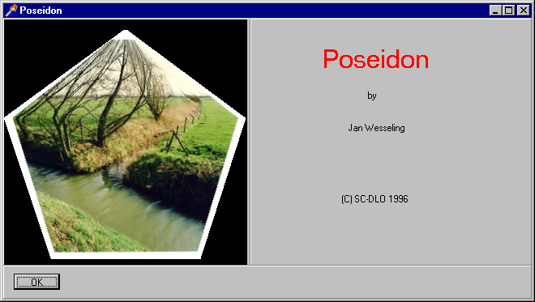
Figure A1.1 Poseidon, initial screen

Poseidon handles output from the extended drainage routine in Swap. Average highest and lowest groundwater levels (GHG and GLG) are calculated (among other things) and groundwater levels, surface water levels and surface water fluxes are displayed graphically both in terms of absolute levels and probability of exceeding a certain value (figure A1.2).

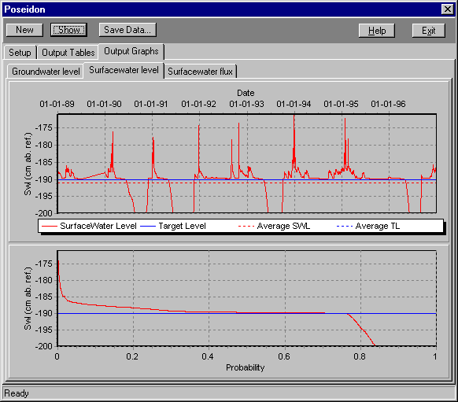

Figure A1.2 Typical output of Poseidon

Jan Wesseling may be contacted at J.G.Wesseling@sc.dlo.nl .
2 SwapWin

Recently Swap has been translated from Fortran to Object Pascal using the Delphi integrated development environment. The result is a true Windows application with all related advantages as real time graphics etc.
Being a new development, SwapWin has not been tested as thoroughly as Swap. It therefore will not be officially supported nor will it be included in the Swap delivery package. People interested in using the program and willingly to accept the as is status of the software may directly contact the author at J.Huygen@sc.dlo.nl .

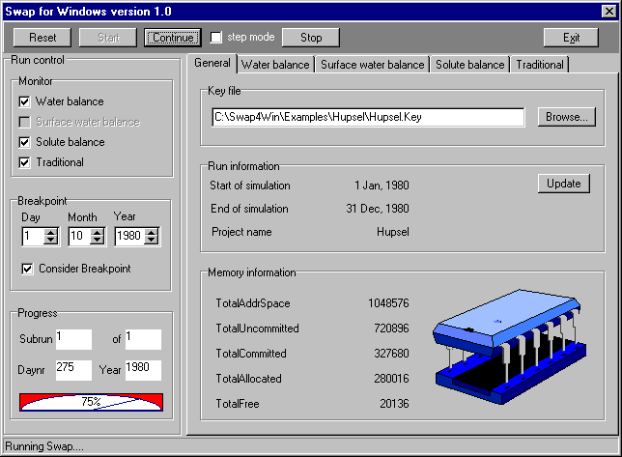
Figure A1.3 Swap for Windows on the run: run interruped after 275 days due to manual set breakpoint.

To run SwapWin specify a key file either by using the browse… option or by filling in the text box. Using the first method, run information is automatically updated, otherwise clicking the ‘Update’ button will be necessary.
Clicking the ‘Start’ button will start the simulation run. The run will proceed till the end of the simulation period unless a breakpoint has been set previously or step mode has been switched on in which case the simulation will be interrupted after each day. Clicking the ‘Continue’ button will resume the run. Clicking the ‘Stop’ button will abort the run prematurely.

Memory information has to be interpreted as follows (Delphi Help information):
TotalAddrSpace The (current) total address space available to your pascal program, in bytes. This will grow as your program's dynamic memory usage grows.
TotalUncommitted The total number of bytes (of TotalAddrSpace) for which space has not been allocated in the swap (something else than Swap, JH )file.
TotalCommitted The total number of bytes (of TotalAddrSpace) for which space has been allocated in the swap file.Note: TotalUncommitted + TotalCommitted = TotalAddrSpace
TotalAllocated The total number of bytes dynamically allocated by your program.
TotalFree The total number of free bytes available in the (current) address space for allocation by your program. If this number is exceeded, and enough virtual memory is available, more address space will be allocated from the OS; TotalAddrSpace will be incremented accordingly.

As the Swap objects are created and destroyed dynamically this is interesting information.

Monitoring the simulation run
The simulation results may be monitored in real time and in several ways (fig. A1.4 to A1.7)
However, viewing a graph during the simulation will increase total calculation time considerably.

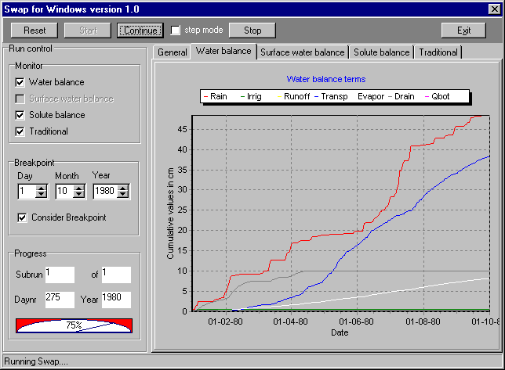
Figure A1.4 Graphical display of water balance terms

Legend

Rain : Cumulative gross rainfall
Irrig : Cumulative gross irrigation applications
Runoff : Cumulative surface runoff
Transp : Cumulative actual crop transpiration
Evapor : Cumulative actual soil evaporation
Drain : Cumulative lateral drainage flow (negative would be infiltration)
Qbot : Cumulative flux through bottom of profile (positive upward)
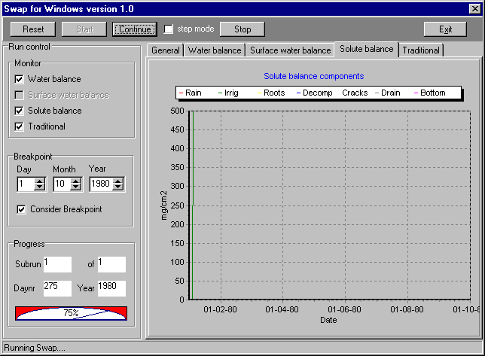
Figure A1.5 Graphical display of solute balance terms

Legend

Rain : Cumulative solute amount in rain water
Irrig : Cumulative solute amount in irrigation water
Roots : Cumulative solute amount taken up by plant roots
Decomp : Cumulative solute amount lost by decomposition
Cracks : Cumulative solute flux through soil cracks
Drain : Cumulative solute flux to drains
Bottom : Cumulative solute amount through bottom of profile

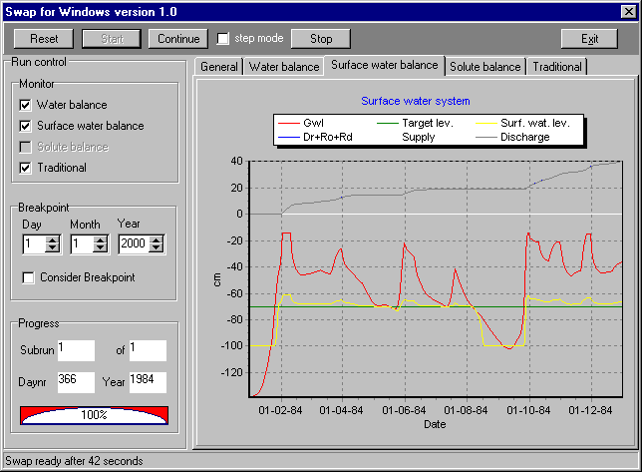
Figure A1.6 Graphical display of surface water balance balance terms
Legend

Gwl : Ground water level
Target lev. : Surface water target level
Surf. wat. lev. : Actual surface water level
Dr+Ro+Rd : Cumulative drainage flux plus runoff flux plus crack flow
Supply : Cumulative water supply to the surface water system
Discharge : Cumulative water discharge from the surface water system

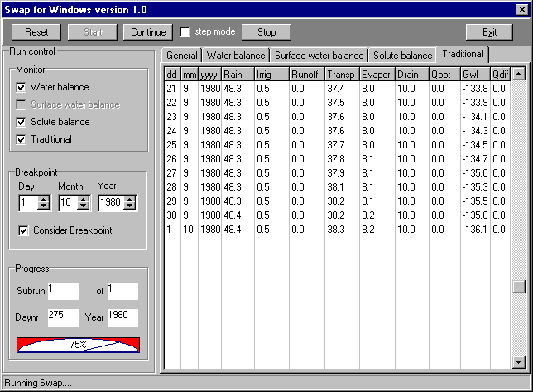
Figure A1.7 Numerical display of waterbalance terms

Legend

Rain : Cumulative gross rainfall
Irrig : Cumulative gross irrigation applications
Runoff : Cumulative surface runoff
Transp : Cumulative actual crop transpiration
Evapor : Cumulative actual soil evaporation
Drain : Cumulative lateral drainage flow (negative would be infiltration)
Qbot : Cumulative flux through bottom of profile (positive upward)
Gwl : Groundwater level
Qdif : Cumulative water balance error

