From: Joop Kroes
Date: 27-June-2006
Subj: Swap3.0.3a released to correct bug in Swap3.0.3: groundwater level as lower boundary condition

Bug in Swap version 3.0.3
When groundwater levels are used as lower boundary condition an incorrect simulation of groundwater levels occurs. This option is activated when in the input file *.swp the switch SWBOTB=1. In that case a table should be specified with the header: “DATE1 GWLEVEL”. The given groundwater levels are not reproduced correctly (see figure 1).

Solution:
Changes in the subroutines UPDATE_STATES and BOCOBOT were implemented. The result was tested (Ruurlo-dataset) and given groundwater levels (in the *.swp-file) were correctly reproduced (figure 2). These changes resulted in Swap version 3.0.3a.

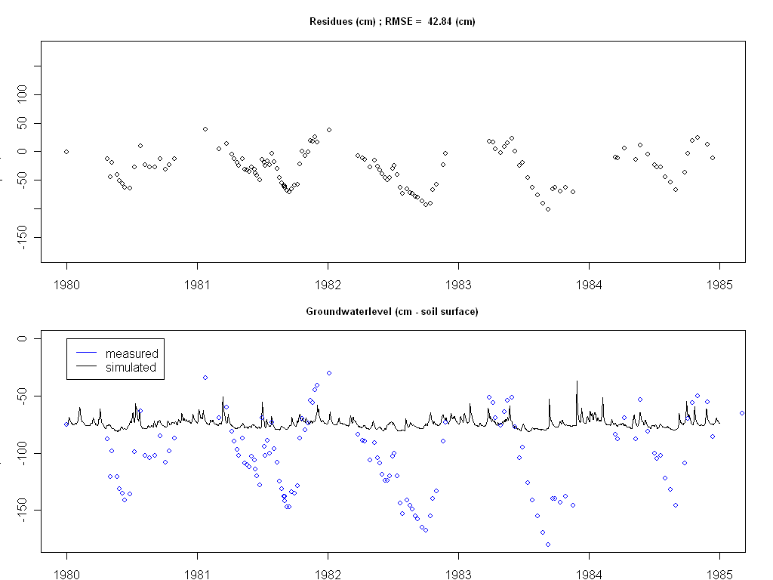 | 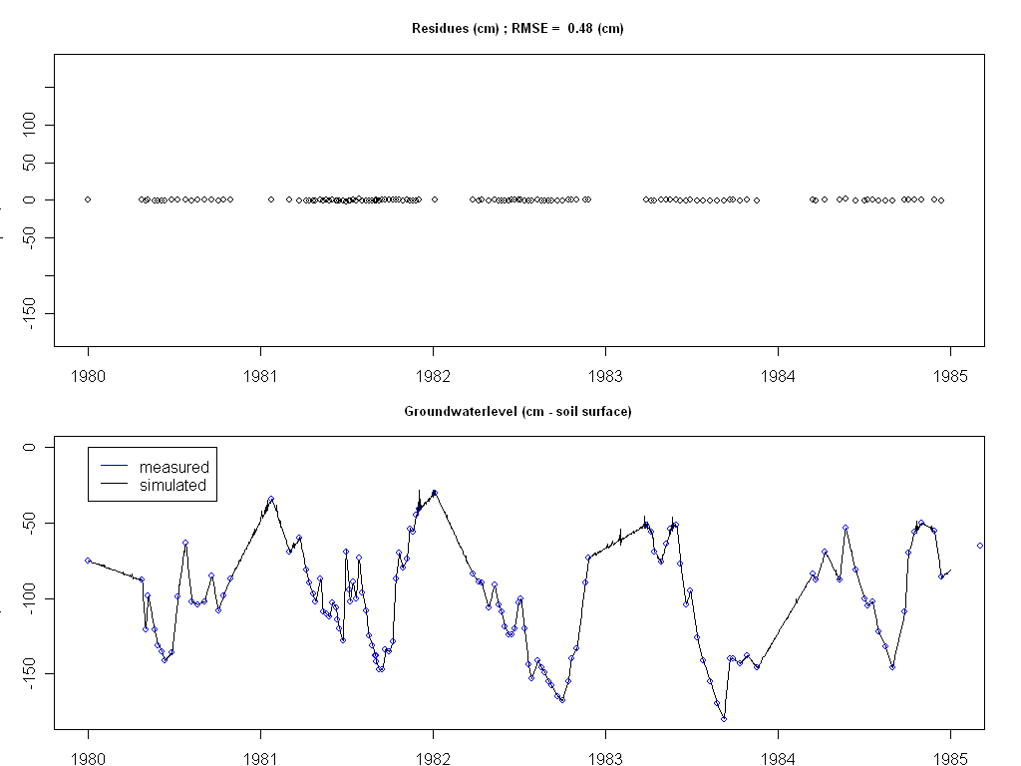
Fig 1. Ground water level as lower boundary using Swap version 3.0.3; RMSE=42.84cm | Fig 2. Ground water level as lower boundary using Swap version 3.0.3a; RMSE=0.48cm

